Functional Design Specification
Initiative A- Standard Naming Convention

File Name: Standard Naming Convention_V3.4_20160523
Version: 3.4
Status: Re-vised
Date: 23 May 2016 (29 April 2013)
Author: TCS / Vodacom

Revision History

Date | Version | Description | Author | Company
08 April 2013 | 1.0 | Initial Draft version for review | TCS | TCS
29 April 2013 | 1.0 | Final version for review and sign-off | TCS | TCS
27 May 2014 | 1.1 | Minor update | Vodacom | Vodacom
14 July 2014 | 2.0 | Updates based on stakeholder feedback | Jacques Blaauw  John Abington  Marika du Plessis | Vodacom
25 Aug 2014 | 2.1 | Updates based on stakeholder feedback | Marika du Plessis | Vodacom
12 Sep 2014 | 2.2 | Updated approval list | Stefan Prinsloo | Vodacom
10 Oct 2014 | 2.3 | Update diagrams | Marika du Plessis | Vodacom
17 Oct 2014 | 2.4 | Update CDN Information | Marika du Plessis | Vodacom
14 Nov 2014 | 2.5 | Include Labelling Products and Power Labels specification | Marika du Plessis | Vodacom
25 Nov 2014 | 2.6 | Include address under Location attributes, Appendix update of CDN nodes | Marika du Plessis | Vodacom
01-Dec-2014 | 2.7 | Updated based on review comments | Vodacom | Vodacom
10-Apr-2015 | 2.8 | Updated new Coriant Node codes, ODF Port, Device Port and Patch Cord Naming to be aligned with ConnectMaster functionality | Vodacom | Vodacom
20 Aug 2015 | 2.9 | Add Fibre Pole Naming and Pole Label Convention, Add rack types, correct one Coriant code | Marika du Plessis | Vodacom
29 Sep 2015 | 3.0 | Add Object Types, Add Algorithm for Location Names with a multiple words, Add Circuit Functions code creation business rules. | Abhishek Kothari | Vodacom
19 Oct 2015 | 3.1 | More detailed Circuit Function code calculation, Add Bandwidth to Value Mapping, Add Pole Manufacturer and Specifications, Add Lesotho Province (Districts) and Codes, confirmed ODF Patch Panel list | Marika du Plessis & Abhishek Kothari | Vodacom
9 Feb 2016 | 3.2 | Update Pole Label specification | Marika du Plessis | Vodacom
26 April 2016 | 3.3 | Update Grafoplast Cable Label Specification | Marika du Plessis | Vodacom
23 May 2016 | 3.4 | Add Power Grid Areas Naming Convention | Marika du Plessis | Vodacom

Contributors

Date | Version | Name | Designation | Company
29 April 2013 | 1.0 | TCS Team | Contractor | TCS
Jun-Aug 2014 | 1.2 | Adrian von Maltitz | NMG OSS | Vodacom
Jun-Aug 2014 | 1.2 | Antoni Gill | TX | Vodacom
Jun-Aug 2014 | 1.2 | Brad Phillips | RAN | Vodacom
Jun-Aug 2014 | 1.2 | Danie Knipe | RAN | Vodacom
Jun-Aug 2014 | 1.2 | David du Plessis | TX | Vodacom
Jun-Aug 2014 | 1.2 | Ian Dunleavy | NQ | Vodacom
Jun-Aug 2014 | 1.2 | Donna Kambarran | NQ | Vodacom
Jun-Aug 2014 | 1.2 | Fanie Van Der Merwe | PM | Vodacom
Jun-Aug 2014 | 1.2 | Gideon Schepers | NQ | Vodacom
Jun-Aug 2014 | 1.2 | Grant Bresler | RAN | Vodacom
Jun-Aug 2014 | 1.2 | Iedereez Mohamed | TX | Vodacom
Jun-Aug 2014 | 1.2 | Anton Meyer | TX | Vodacom
Jun-Aug 2014 | 1.2 | Ben Visser | RAN | Vodacom
Jun-Aug 2014 | 1.2 | Ignatius Ferreira | RAN | Vodacom
Jun-Aug 2014 | 1.2 | Johan Kleynhans | CORE | Vodacom
Jun-Aug 2014 | 1.2 | Leon Nadan | CORE | Vodacom
Jun-Aug 2014 | 1.2 | Lloyd Mphahlele | TX | Vodacom
Jun-Aug 2014 | 1.2 | Miles Yarrington | NMG OSS | Vodacom
Jun-Aug 2014 | 1.2 | Neliswa Sango | TX | Vodacom
Jun-Aug 2014 | 1.2 | Nesham Balmogim | FM | Vodacom
Jun-Aug 2014 | 1.2 | Neville Green | CORE | Vodacom
Jun-Aug 2014 | 1.2 | Regan Govender | VB / EBU | Vodacom
Jun-Aug 2014 | 1.2 | Chris Reid | CORE | Vodacom
Jun-Aug 2014 | 1.2 | Charl Louw | VB / EBU | Vodacom
Jun-Aug 2014 | 1.2 | Marius Beukes | VB / EBU | Vodacom
Jun-Aug 2014 | 1.2 | Surajh Seelajith | TX | Vodacom
Jun-Aug 2014 | 1.2 | Thome Theron | NMG OSS | Vodacom
Jun-Aug 2014 | 1.2 | Trevor Eckleton | TX | Vodacom
Jun-Aug 2014 | 1.2 | Ursula George | RAN | Vodacom
Jun-Oct 2014 | 1.3 | Fred Albrecht | CDN | Vodacom
Jun-Oct 2014 | 1.3 | Peet Uys | CDN | Vodacom
Jun-Oct 2014 | 1.3 | Jacques Hendricks | CDN | Vodacom
Jun-Oct 2014 | 1.3 | Jurgen du Plessis | CDN | Vodacom

Signoff
This table serves as an acceptance table and once signed by all parties, this document is deemed to be accepted. The Detailed Design will be drawn up from this document and no additional changes shall be made that do not appear in this signed off document.

Date | Vers | Name | Designation & Business Area / Internal Customer | Signature
 | 1.2 | Andries Delport | Chief Technology Officer
 | 1.2 | Christoph Labuschagne | Network Operations Officer
 | 1.2 | Johann Pretorius | ME: Enterprise Technology
 | 1.2 | Shane Hibbard | ME: Gauteng Region
 | 1.2 | Andries Steenkamp | ME: Core & Transport Network Engineering
 | 1.2 | Alberts Breed | ME: KwaZulu Natal Region
 | 1.2 | Steven Barnwell | ME: Western Cape Region
 | 1.2 | Louisa van Beek | ME: Mpumalanga Region
 | 1.2 | Carol Hall | ME: Eastern Cape Region
 | 1.2 | Jorge Mendes | ME: Central Region
 | 1.2 | Thys Delport | ME: Network Programme Management
 | 1.2 | Henry Arnold | EHOD: NMG OSS
 | 1.2 | Fabian Leite | Principal Specialist: NMG Services Design
 | 1.2 | Lester Grovers | Manager: NMG OSS: Planning, Config and Inventory
 | 2.2 | Marika du Plessis | Senior Specialist: Transmission Process, Planning & Configuration Management | 

Distribution

Date | Version | Name | Designation | RACI
2014-08-25 | 1.2 | Naming Convention Stakeholders Group | Various

RACI | Description
Responsible | Those who do work to achieve the task. The role of Responsible includes support, which is to provide resources to complete the task. (such as the author)
Accountable | Also Approver or final Approving authority  Those who are ultimately accountable to the correct and thorough completion of the task. Accountable is the one to whom “R(s)” are accountable.  In other words, A must sign off (Approve) on work that R provides.  There must be only one A specified for each task.  The role of Accountable may include Responsible. In other words, it is not unusual that the one who is Accountable for a task is also Responsible to do the work to achieve the task.
Consulted | Those whose opinions are sought. Two-way communication. (may include reviewer)
Informed | Those who are kept up up-to-date on progress. One-way communication.

DOCUMENT CONTROL
This document is controlled in accordance with the procedures indicated in document ___________”.

CONTROLLED DISTRIBUTION LIST
Once updated, a copy of the latest revision will be saved in the document management system in use. An e-mail to this effect will be sent to the relevant personnel or heads of department.
Copy No. | Owner | Location

DOCUMENT CHANGE HISTORY
ISSUE NO | DATE ISSUED | ISSUED BY | CHANGE DESCRIPTION
Draft | 08-Apr-2013 | TCS | Draft Version
Final | 29-Apr-2013 | TCS | OSP part updated and final version released
Minor Update | 29-May-2014 | Vodacom | Added section 1.2
Additional Updates | 17-Jul-2014 | Vodacom | Updated all Figures in document with new diagrams and tables
Additional Updates | 8 to 21-Aug-2014 | Vodacom | Added Ducts and Trenches, CDN equipment, WiFi information etc
Final Updates | 25 Aug 2014 | Vodacom | Final Format Checks. Added additional Node functionalities in Table, added additional Nodes and Codes
Phase 2 Updates | 10 Oct – 25 Nov 2014 | Vodacom | Update diagrams  Update CDN Information  Include Labelling Products and Power Labels specification  Include address under Location attributes, Appendix update of CDN nodes
Additional Updates | 20 Mar – 10 Apr 2015 | Vodacom | Updated new Coriant Node codes, ODF Port, Device Port and Patch Cord Naming

ABBREVIATIONS, ACRONYMS AND DEFINITIONS

ABBREVIATIONS | DESCRIPTION
3G | 3rd generation
AGR | Aggregation Layer
ALU | Alcatel-Lucent
AP | Access Point (Wi-Fi)
API | Application Programming Interface
ATM | Asynchronous Transfer Mode
BSS | Business Support Systems
BTS | Base transceiver station
BW | Bandwidth
CCMDB | Change and Configuration Management Database
CDMA | Code division multiple access
CDN | Content Delivery Network
CORBA | Common Object Request Broker Architecture
CoS | Class of Service
COTS | Commercial off-the-shelf
DWDM | Dense wavelength division multiplexing
E2E | End to End
eTOM | enhanced Telecom Operations Map
FAQ | Frequently asked questions
GSM | Global System for Mobile Communications
GTM | Go To Market
GUI | Graphical User Interface
Handhole | See Manhole
HLR | home location register
HP | Hewlett Packard
HPSD | HP Service Desk
IMS | IP Multimedia Subsystem
IMS | Inventory Management System
IN | Intelligent Network
IP | Internet Protocol
ISP | Inside Plant (cabling and equipment installed in a telecom operators facility)
IT | Information Technology
ITU-T | International Telecommunication Union –Telecommunication Standardization Sector
KPIs | Key Performance Indicators
L2 | Layer 2
L3 | Layer 3
L4 | Layer 4
LTE | Long Term Evolution
Manhole | In this document the term Manhole is used to refer to either Manholes & Handholes
MTTR | Mean time to repair
N/W | Network
NE | Network Element
NERA | National Employment Rights Authority
NGN | Next-generation network
NGOSS | New Generation Operations Systems and Software
NMC | Network Management Centre
NMS/EMS | Network Management System/ Element Management System
NOC | Network Operations Center
NSN | Nokia Siemens Networks
O&M | Operations & Maintenance
OCM | Organizational Change Management
ODF | Optical Distribution Frame
OSP | Outside Plant (physical cabling and supporting infrastructure such as conduit, tower, manholes, etc. between two facilities)
RAN | Radio Access Network
SDH | Synchronous Digital Hierarchy
SDK | Software Development Kit
SDLC | Systems Development Life cycle
SI | Systems Integration
SIA | Service Impact Analysis
SID | Shared Information Data Model
SIT | System Integration Testing
SLA | Service-level agreement
SMBs | Small and Medium Businesses
SMEs | Subject Matter Experts
SMS | Short Message Service
SNMP | Simple Network Management Protocol
SO | Strategic Outsourcing
SOA | Service Oriented Architecture
SOAP | Simple Object Access Protocol
SOC | Service Operations Center
STM | Synchronous Transport Module
TCS | Tata Consultancy Services
uCMDB | Universal Configuration Management Database
VC | Virtual Container
VLAN | Virtual Local Area Networks
WiFi | Local Area Wireless Technology
WiMAX | Worldwide Interoperability for Microwave Access

RELATED DOCUMENTS

Document number and title | Publishing Organization | Version | Date | LOCATION
OSM Quickwins SOW | TCS | V 2.3 |  | MS Sharepoint
Analysis Document-Naming Convention_V 1.4 | TCS | V 1.4 |  | MS Sharepoint
Iterative Design Workshop – Initiative A V1.3 | TCS | V 1.3 |  | MS Sharepoint

Table of Contents
1 Introduction 15
1.1 Scope 15
1.2 Benefits 15
1.2.1 Central & Regional Network Planning Teams 15
1.2.2 Network operations centre 15
1.3 Objective 16
2 Design 18
2.1 Power Grid Area 21
2.1.1 Power Grid Area Hierarchy 21
2.1.2 Power Grid Area Object 21
2.2 Location 22
2.2.1 Location Hierarchy 22
2.2.2 Location Object 22
2.2.3 Location Attributes 23
2.3 Node 25
2.3.1 Node Naming Convention 25
2.3.2 Node Naming Components 26
2.3.3 Node Attributes 27
2.4 Link (Physical Link) 28
2.4.1 Link Naming Convention 28
2.4.2 Link Naming Components 28
2.4.3 Link Attributes 29
2.5 Circuit (Logical Link) 31
2.5.1 Circuit Naming Convention 31
2.5.2 Circuit Naming Components 31
2.5.3 Circuit Attributes 47
2.6 Cell 49
2.6.1 Cell Naming Convention 49
2.6.1 Cell Attributes 49
2.7 RACK 50
2.7.1 Rack Naming Convention 50
2.7.2 Rack Naming Components 50
2.7.3 Rack Attributes 51
2.8 ODF / Patch Panel 52
2.8.1 ODF / Patch Panel Naming Convention 52
2.8.2 ODF / Patch Panel Naming Components 52
2.8.3 ODF / Patch Panel Attributes 53
2.9 ODF / Patch Panel Port 54
2.9.1 ODF / Patch Panel Port Naming Convention 54
2.9.2 ODF / Patch Panel Port Naming Components 54
2.9.3 ODF / Patch Panel Port Attributes 54
2.10 Device Port (For ISP) 55
2.10.1 Device Port Naming Convention 55
2.10.2 Device Port Naming Components 55
2.10.3 Device Port Attributes 55
2.11 Patch Cord 56
2.11.1 Patch Cord Naming Convention 56
2.11.2 Patch Cord Naming Components 56
2.11.3 Patch Cord Attributes 57
2.12 Manhole 57
2.12.1 Manhole Naming Convention 57
2.12.2 Manhole Naming Components 57
2.12.3 Manhole Attributes 58
2.13 Pole for Overhead Fibre 59
2.13.1 Pole Naming Convention 59
2.13.2 Pole Naming Components 59
2.13.3 Pole Attributes 60
2.14 Splice Closure 60
2.14.1 Splice Closure Naming Convention 60
2.14.2 Splice Closure Naming Components 62
2.14.3 Splice Closure Attributes 62
2.15 Duct 63
2.15.1 Duct Naming Convention 63
2.15.2 Duct Naming Components 63
2.15.3 Duct Attributes 64
2.16 Trench 65
2.16.1 Trench Route Naming Convention 65
2.16.2 Trench Route Naming Components 65
2.16.3 Trench Attributes 66
2.16.4 Trench Sector Naming Convention 67
2.16.5 Trench Sector Naming Components 68
2.17 Cable 68
2.17.1 Cable Naming Convention 68
2.17.2 Cable Naming Components 69
2.17.3 Cable Attributes 70
3 References 72
3.1 Naming Convention Tool 72
4 Appendix 73
4.1 Country Code 73
4.2 ZA Province Code 73
4.3 LS Province (District) Code 73
4.4 Power Grid Area 74
4.5 Location Code Generation Algorithm 74
4.6 Type of site 76
4.7 Site Owner 77
4.8 Vodacom Operating Region 77
4.9 POC Type 77
4.10 Node / Device Type Code 78
4.11 Business Area / Internal Customer 83
4.12 Node Status 83
4.13 Node Functionality 85
4.14 Link Medium 86
4.15 Link Bandwidth and Bandwidth Code 86
4.16 Protection Type 87
4.17 Link Operator Type 87
4.18 Link Status 87
4.19 Circuit Function Code 88
4.20 Bandwidth to Value Mapping 90
4.21 Circuit Status 91
4.22 Circuit Service Type 91
4.23 Rack Type Code List 92
4.24 ODF / Patch Panel Type Code List 92
4.25 Cable Type Code List 92
4.26 Cable Manufacturer List 93
4.27 Civil works/Fibre Build Contractor List 93
4.28 Fibre Size Code List 93
4.29 Network Type Code List 94
4.30 Cable Owner List 94
4.31 Cable Request Type 94
4.32 Duct Type 95
4.33 Rack Owner 95
4.34 Manhole Type Attribute List 95
4.35 Pole Manufacturer and Specification 96
4.36 Vodacom Counties 96
4.37 Physical Trunk Types 97
4.38 Broadband Interface Types 98
4.39 Product Specification for Cable Labels 98
4.40 Power Components to be labelled: 99
4.41 Vodacom Manhole and/or Pole Label Specification: 100

Table List
Table 1 Object List 16
Table 2 Object List out of scope 17
Table 3 Vodacom Objects mapped to Standard Object Type 20
Table 4 Power Grid Type Relationships 21
Table 5 Location Type Relationships 23
Table 5 Location Attributes 24
Table 6 Node Naming Components 26
Table 7 Node Attributes 27
Table 8 Link Naming Components 28
Table 9 Link Attributes 30
Table 10 Circuit Naming Components 31
Table 11 Circuit Types for SDH& PDH Transmission & CDN 33
Table 12 Circuit Types for IP Transmission & CDN 37
Table 13 NSN 3G RAN Access Logical Links 39
Table 14 Huawei 3G RAN Access Logical Links 40
Table 15 NSN 2G RAN Core Logical Links 41
Table 16 NSN 3G RAN Core Logical Links 42
Table 17 Huawei 2G RAN Core Logical Links 42
Table 18 Huawei 3G RAN Core Logical Links 43
Table 19 Circuit Types and Circuit Type Code for Mobile Core Logical Links 44
Table 20 Circuit Attributes 47
Table 21 Rack Naming Components 50
Table 22 Rack Attributes 51
Table 23 ODF / Patch Panel Naming Components 52
Table 24 ODF / Patch Panel Attributes 53
Table 25 ODF / Patch Panel Port Naming Components 54
Table 24 ODF / Patch Panel Port Attributes 54
Table 26 Device Port Naming Components 55
Table 24 ODF Port Attributes 55
Table 27 Patch Cord Naming Components 56
Table 30 Manhole Naming Components 58
Table 31 Rack Attributes 58
Table 32 Manhole Naming Components 59
Table 29 Rack Attributes 60
Table 30 Splice Closure Naming Components 62
Table 31 Splice Closure Attributes 62
Table 32 Cable Naming Components 63
Table 33 Splice Closure Attributes 64
Table 34 Trench Naming Components 65
Table 35 Splice Closure Attributes 66
Table 34 Trench Naming Components 68
Table 36 Cable Naming Components 69
Table 37 Splice Closure Attributes 70
Table 43 Country Code _Country_Attributes 73
Table 44 Province Code _Province_Attributes 73
Table 44 Province Code _ LS Province (District)_Attributes 73
Table 44 Power Grid Areas 74
Table 45 Type of Site 76
Table 46 Site Owner 77
Table 47 Operating Region 77
Table 43 POC Type for Site 77
Table 49 Device Type Code 83
Table 50 Business Area / Internal Customer 83
Table 46 Node Status 84
Table 53 Node Functionality 85
Table 54 Link Type and Link Type Code 86
Table 55 Link Bandwidth and Bandwidth Code 86
Table 56 Protection Type 87
Table 57 Link Operator Type 87
Table 58 Link Status 87
Table 59 Circuit Function Code 90
Table 60 Bandwidth to Value Mapping 91
Table 61 Circuit Status 91
Table 62 Circuit Service Type 91
Table 63 Rack Type List 92
Table 64 ODF / Patch Panel Type List 92
Table 65 Cable Type List 92
Table 66 Cable Manufacturer List 93
Table 67 Cable Supplier List 93
Table 68 Fibre Size List 93
Table 69 Network Type List 94
Table 70 Cable Owner List 94
Table 71 Cable Request Type 95
Table 72 Duct Type List 95
Table 73 Rack Owner 95
Table 74 Manhole Type List 96
Table 75 Pole Manufacturer and Specification List 96
Table 76 Vodacom Counties 97
Table 77 Trunk Types 98
Table 78 Broadband Interface Types 98
Table 79 Product Specification for Cable Labels 99
Table 80 Broadband Interface Types 100
Table 82 Vodacom Manhole or Pole Label Specification 100

Table of Figure
Figure 1 Power Grid Area Hierarchy 21
Figure 2 Location Hierarchy 22
Figure 2 Node Naming Convention 26
Figure 3 Link Naming Convention 28
Figure 4 Circuit Naming Convention 31
Figure 5 Tellabs Network Architecture 34
Figure 6 PDH Circuit Hierarchy with STM between 6300 and 8100 34
Figure 7 PDH Circuit Hierarchy with E1 between 6300 and 8100 35
Figure 8 PDH Circuit Hierarchy with Concatenation of VC12’s 35
Figure 9 VC4 concatenation scenarios 35
Figure 10 EoS Scenario 36
Figure 11 SDH Circuit Hierarchy 36
Figure 12 SDH Circuit Hierarchy with Concatenation of TU12, TU3 and AU4 36
Figure 13 VPN Circuit Hierarchy back 37
Figure 14 Ethernet Ring 38
Figure 15 NSN 2G RAN Access Logical Links 39
Figure 16 NSN 3G IuB Hierarchy 39
Figure 17 Huawei 2G RAN Access Logical Links 40
Figure 18 Huawei 3G IuB Hierarchy 41
Figure 19 NSN 2G RAN Core Circuit Hierarchy 41
Figure 20 NSN 3G RAN Core Circuit Hierarchy 42
Figure 21 Huawei 2G RAN Core Circuit Hierarchy 43
Figure 22 Huawei 3G RAN Core Circuit Hierarchy 44
Figure 23 STP Links 45
Figure 24 Signalling and Traffic between MSC and BSC 45
Figure 25 Signalling and Traffic between MSS and MGW 46
Figure 26 Trunk Groups from MSCs to other Nodes 46
Figure 27 Cell Naming Convention 49
Figure 28 Rack Naming Convention 50
Figure 29 ODF/ Patch Panel Naming Convention 52
Figure 30 ODF / Patch Panel Port 54
Figure 32 Device Port Naming Convention 55
Figure 34 Manhole Naming Convention 57
Figure 35 Duct Naming Convention 63
Figure 36 Trench Route Naming 65
Figure 37 Trench Sector Naming Convention 67
Figure 38 Cable Naming Convention 68

Introduction

Scope

- Implement a Standard Naming Convention across the different domains; Transport, RAN, and Core. Most of the IP domain will be included in the next phase of the Standard Naming Convention project.
- This includes end-to-end process across the different domains to fill the existing gaps and ensure consistent use of the Naming Convention

Benefits

Central & Regional Network Planning Teams

- Efficient and proficient planning of services which avoid order rejections and rework
- Improve inventory keeping and management for capacity and traffic management over the circuits
- Easy identification of resources during planning
- Can be easily extended to any new vendor or technology in the future

Network operations centre

- Improved MTTR and location of faults
- Will enable pro-active monitoring of faults due to unification of names within network entities
- Will enable efficient service to Network Correlation and Service Impact Analysis in the case of any fault. This will help ensure that the customer is proactively informed.

Objective
The objective of the Initiative is to define a Standard Naming Convention for ISP (Active) and OSP (Passive) objects. The following table gives the list of objects currently named in Vodacom for active and passive equipment.
Technology | Object
Transmission | Site
 | Node
 | Link
 | Trunk
 | Tunnel
 | Pseudowire
 | IP MPLS Trunk
 | Service Circuit
RAN | Site
 | BTS
 | BSC
 | RNC
 | NodeB (add LTE stuff)
 | Cell
Core | Site
 | HLR
 | VLR
 | GGSN
 | SGSN
 | STP
 | MSS
 | MGW (Add LTE stuff)
 | Power Grid Area
OSP | Site
 | Rack
 | Ducts
 | ODF
 | Cable
 | Manhole
 | Patch Panel
 | Splice Tray
CDN | Site
 | Nodes
 | Links
 | Trunk
 | Tunnel
 | IP MPLS Trunk
 | Service Circuit
Table 1 Object List

List of objects for which the design will be covered in next phases.

Technology | Object
ISP | Rectifiers
 | Batteries
 | Generators
 | Fire Suppression
 | Extinguishers
 | Detectors
 | Air Conditioners
 | Power Supply Authority
 | Power Meter
 | Site Controller
 | Alarm/Security
 | Earth Cables
 | Earth Bars/Spikes
 | Lightning Protection
 | Manholes
 | Masts/Towers
Table 2 Object List out of scope

Design

The table below gives the definition of the Standard Object Types considered for defining Naming Convention

The following section explains the mapping of the Standard Object Types with Vodacom Network entities.
Technology | Object | Mapped Standard Object Type
Transmission | Site | Location
 | Node | Node
 | Trunk | Link
 | Tunnel | Circuit
 | Pseudowire | Circuit
 | IP MPLS Trunk | Circuit
 | Service Circuit | Circuit
RAN | Site | Location
 | BTS | Node
 | BSC | Node
 | RNC | Node
 | NodeB | Node
 | Cell | Cell
Core | Site | Location
 | HLR | Node
 | VLR | Node
 | GGSN | Node
 | SGSN | Node
 | STP | Node
 | MSS | Node
 | MGW | Node
OSP | Site | Location
 | Rack | Rack
 | Sub Rack | Node
 | ODF | ODF
 | Pole | Pole
 | Splice Closure | Splice Closure
 | Duct | Duct
 | Trench | Trench
 | Patch Cord | Patch Cord
 | Cable | Cable
 | Manhole | Manhole
 | Patch Panel | Patch Panel
CDN | Site | Site
 | Node | Node
 | Link | Link
 | Trunk | Link and Circuit
 | Tunnel | Circuit
 | IP MPLS Trunk | Circuit
 | Service Circuit | Circuit
Table 3 Vodacom Objects mapped to Standard Object Type

Power Grid Area

Power Grid Area Hierarchy
Figure 1 shows the Proposed Power Grid Hierarchy. The new Power Grid hierarchy is based on South Africa’s geographic boundaries starting from Country, Province (9 Geographical Provinces), and then the Power Grid Area Name.

Country will be the highest level for the Power Grid Area Object. Province will be the next level of Power Grid Area Object and will be created under a country when the user wants to add a new Province using the Naming Convention Tool. The Power Grid Areas of Eskom are mapped according to the 9 Geographical Provinces and this is less likely to change.

The last level of Power Grid Area Object will be a Power Grid Area Name. The Power Grid Area can be mapped to Vodacom Locations (sites) which contains attributes such as Vodacom Operational Region and County for Fault Management. Short Codes will be generated automatically for all Location Objects including Site when the Location Object is getting created using the Naming Convention Tool (Refer section 3.1 Naming Convention Tool)

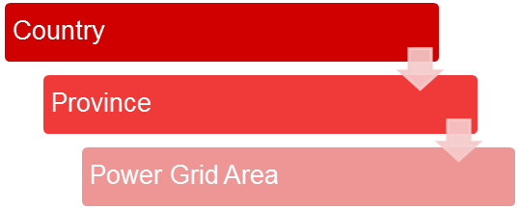

Figure 1 Power Grid Area Hierarchy

Power Grid Area Object
Following table shows the Power Grid Area type relationships with example.
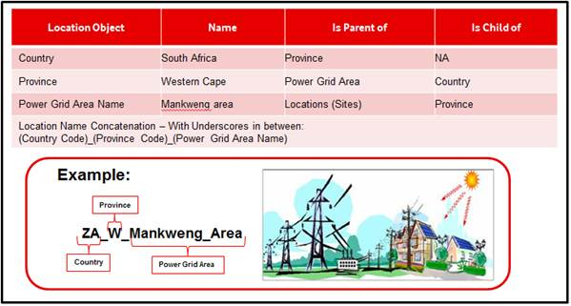
Table 4 Power Grid Type Relationships

Location

Location Hierarchy
Figure 2 shows the Proposed Location Hierarchy. The new location hierarchy is based on South Africa’s geographic boundaries starting from Country, Province (9 Geographical Provinces), and Location.

Country will be the highest level Location Object. Province will be the next level of Location Object and will be created under a country when the user wants to add a new Province using the Naming Convention Tool.

The last level of Location Object will be a Site which will be created under a building. Short Codes will be generated automatically for all Location Objects including Site when the Location Object is getting created using the Naming Convention Tool (Refer section 3.1 Naming Convention Tool)

Figure 2 Location Hierarchy

Location Object
Following table shows the location type relationships with example.
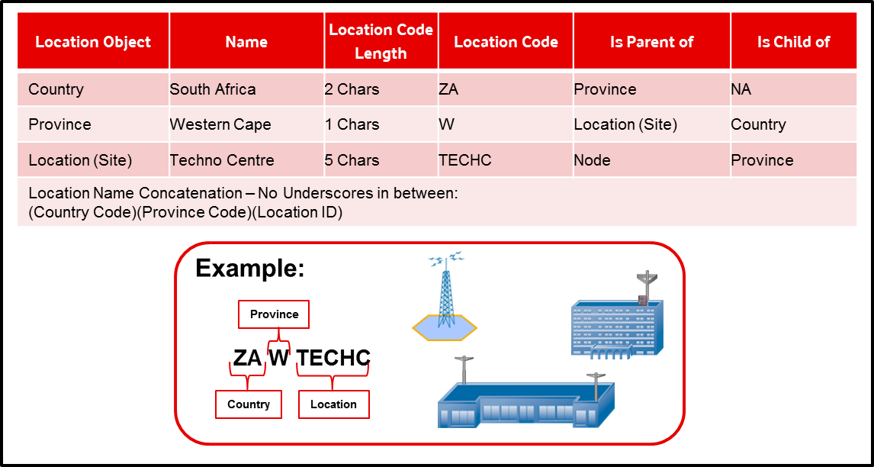

Table 5 Location Type Relationships

Location Attributes
Following table gives the attributes for the Location Objects.

Location Entity | Attribute Name | Attribute Type | Example
Country | Country Code | Automatic | ZA for South Africa  Refer section 4.1 Country Code for the list of all countries with their code
Province | Province Code | Automatic | W for Western Province  Refer section 4.2 Province Code
Location | Location Name | Mandatory | The location name will be imported from tools being used in the existing process (e.g. Site Name from Atoll)
 | Location Code | Automatic | TECCE for Techno Centre (Location code will use the Location Name & apply an algorithm to determine the location code)  Refer section 4.3 Location Code Generation Algorithm
Location Address | Street Number | Optional | 23
 | Street Name | Mandatory | Vodacom Boulevard
 | Building Number | Optional | 01
 | Building /Farm Name/Settlement | Mandatory | Vodacom Corporate Park
 | Suburb / Subplace/ District | Mandatory | Noordwyk
 | City / Town | Mandatory | Midrand
Location  Co-ordinates | Latitude | Mandatory | -26.15072222
 | Longitude | Mandatory | 28.03397222
Other Location  Detail | Operating Region | Automatic | Operation region to be determined based on location (LAT/LON), e.g. WES  Refer section 4.6 Vodacom Operating Region
 | County | Automatic | County to be determined based on location (LAT/LON), e.g.WES_RC  Refer section Table 67 POC Type
 | Site Owner | Mandatory | Vodacom  Refer section 4.5 Site Owner
 | BS Number | Automatic | 0022679
 | Atoll ID | Automatic for RAN Site | SGA_8087
 | POC Type | Mandatory – Manually for interim | POC1  Refer section 4.7 POC Type
 | Floor | Optional | 1,2,3,4 etc
 | Sub floor | Optional | 1a, 1b etc
 | Room | Optional | NIS Meeting Room
 | Type of Site | Mandatory
Table 5 Location Attributes

Location Attributes
The following section explains the attributes on the location object.

Street Number
This attribute captures the number of the street according to cadastral information. This is not a mandatory field, due to some of our locations which are in rural areas
The Street number will be imported from tools used in the existing process flow (e.g. TxMan).

Street Name

This attribute captures the street name where the Location is located. This is a mandatory field and should be captured as far as possible.

The Street name will be imported from tools used in the existing process flow (e.g. TxMan).

Building Number
This attribute captures the number of the building for urban areas. This is not a mandatory field, due to some of our locations situated in rural areas.
The building number will be imported from tools used in the existing process flow (e.g. TxMan).

Building Name/Farm Name/ Settlement
This attribute captures the Building Name for urban areas and in case of rural areas, this attribute will capture the farm names.
The building name will be imported from tools used in the existing process flow (e.g. TxMan).

Suburb / Subplace/ District
This attribute captures the suburb or subplace or distict of the location.
The Suburb / Subplace will be imported from tools used in the existing process flow (e.g. TxMan).

City / Town
This attribute captures the City or Town of the location.
The City / Town will be imported from tools used in the existing process flow (e.g. TxMan).

Latitude
This attribute captures the geographical latitude of the location.
The Latitude will be imported from tools used in the existing process flow (e.g. Atoll). Decimal format will be used, e.g. -26.15072222

Longitude
This attribute captures the geographical longitude of the location.
The Longitude will be imported from tools used in the existing process flow (e.g. Atoll). Decimal format will be used, e.g. 28.03397222

Operating Region
This attribute will capture the Operating Region for a site. The attribute will be automatically determined based on the geographical location information (LAT/LON) of the location. Refer section 4.6 Vodacom Operating Region

County
This attribute will contain the County for a site. The attribute will be automatically determined & imported based on the geographical information (LAT/LON) of the location. Refer section 4.6 Vodacom Operating Region

Site Owner
This attribute will capture as to who owns the site i.e. if the site is owned by Vodacom, Telkom, MTN, Cell C, Neotel, etc. The attribute will be imported from either Atoll or TX Manager depending of the type of site. Refer section 4.5 Site Owner

BS Number
This attribute will capture the BS number of a site generated from Atoll for RAN Site and TX SOM for rest of the sites. The attribute will imported as part of the site creation process.

Atoll ID
This attribute will capture the Atoll ID of a site generated from Atoll. The attribute will be imported as part of the site creation process. It will be null for other sites apart from RAN sites.

POC Type
This attribute will POC Type for the site. The attribute will be a drop-down which the user will select while updating a site using Connect Master. Consideration is currently being given to automate the POC type based on existing algorithms.
Refer section 4.7 POC Type

Floor
This attribute will capture the floor number of the location if the location is based in a building. The attribute will be a free text box which the user will populate while updating a site using ConnectMaster. Spaces will not be allowed.
For e.g.: Floor-1

Sub-Floor
This attribute will capture the sub-floor number of the location if the location is based in a building. The attribute will be a free text box which the user will populate while updating a site using ConnectMaster. Spaces will not be allowed.
For e.g.: Floor_1A

Room
This attribute will capture the room of the location if the location is based in a building. The attribute will be a free text box which the user will populate while updating a site using ConnectMaster. Spaces will not be allowed.
For e.g.: NMC_Room_Techno_Centre_Building

Type of Site
The attribute will be a dropdown which the user will select while creating a site under a building using the naming convention tool. Refer section 4.4 Type of site

Node

Node Naming Convention
Below is the proposed naming convention for Node.

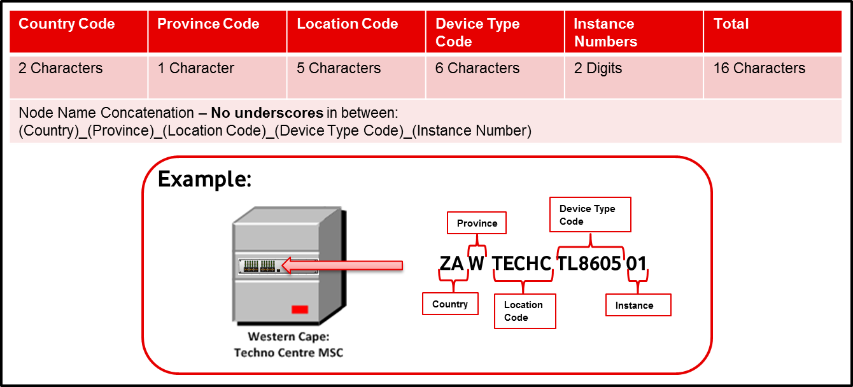
Figure 2 Node Naming Convention

Node Naming Components
The following table gives the components of the new naming convention.
Node Naming Components | No of Characters | Example
Country Code | 2 Characters | ZA
Region Code | 1 Character | W
Location Code | 5 Characters | TECHC
Device Type Code | 6 Characters | TL8605  Refer section 4.8 Node / Device Type Code
Instance Number | 2 digits | 01
Table 6 Node Naming Components

Location Component
User will first select the site where the node is to be placed.
The Site will be created as per Table 3 Location Type Relationships
The Country Code, Province Code and the Location Code will be automatically derived from the location name and location’s attributes.

Device Type Code Component
The list of Model type as per vendor selected, will be available as a drop down which the user will select using the Naming Convention tool. Refer section 4.8 Node / Device Type Code. Type Code will be automatically generated by the tool while adding the new types as a part of metadata creation. List in the appendix section if for example.

Instance Number
The Instance Number will be calculated automatically. The instance number will be incremented per node under a particular location based on the vendor and model of the device.

Node Attributes
Based on the requirements and data analysis, there are certain components which are captured part of name but can be derived from a relationship or attribute value.

Following table gives the attributes which are required to be filled while generating the new Node name.
Attribute Name | Attribute Type | Character Length | Example
Business Area / Internal Customer | Mandatory | Enumeration | Enterprise Business Unit  Refer section
Status | Mandatory | Enumeration | In Service  Refer section 4.10 Node Status
Parent Node  (This will be applicable to BTS,BSC, RNC and NodeB) | Mandatory for specific Nodes | 16 Characters | ZAGMIDRNHW390001
Functionality | Mandatory | Enumeration | BTS (Add CDN’s)  Refer section 4.11 Node Functionality
Protection Type | NA | NA | This will be covered when IMS is implemented.  Refer section 4.14 Protection Type
Bay | Optional |  | A:02
Table 7 Node Attributes

Business Area / Internal Customer Attribute
Different naming conventions are followed in Tellabs node as per the Business Area / Internal Customers. The same will be captured as part of the Business Area / Internal Customer attribute for nodes.
Business Area / Internal Customer will appear as a drop down to users when they are generating node name using the Naming Convention Tool. Business Area / Internal Customer

Status Attribute
The current RAN Naming Convention contains the status of the node in the name.
For eg: When the node is planned the BTS name contains “NEW”. This component will be stored as an attribute to the node. The attribute will be a dropdown which the user will select while generating the node name using the Naming Convention Tool. Refer section 4.10 Node Status for the list of statuses

Parent Node Attribute
In existing RAN Naming Convention, the BTS name contains the parenting BSC area name and the BSC name contains the parenting MSC name, therefore this attribute will be applicable for RAN nodes only. The attribute will be a drop-down box where users will select parenting node name while updating the BTS/ BSC/ NodeB/ RNC name using Naming Convention Tool.

Functionality Attribute
Technology related information like 2G/3G or LTE are currently being captured in name of RAN Node. This attribute will be provided for users to capture this information. BTS value is equivalent to 2G, NodeB is equivalent to 3G and eNodeB is equivalent to LTE. This will be applicable for RAN nodes and the Mobile Core nodes. The attribute will be a drop down and the user will select the value while generating the node name using the Naming Convention Tool. Refer section 4.11 Node Functionality

Link (Physical Link)

Link Naming Convention
Below is the proposed naming convention for Link

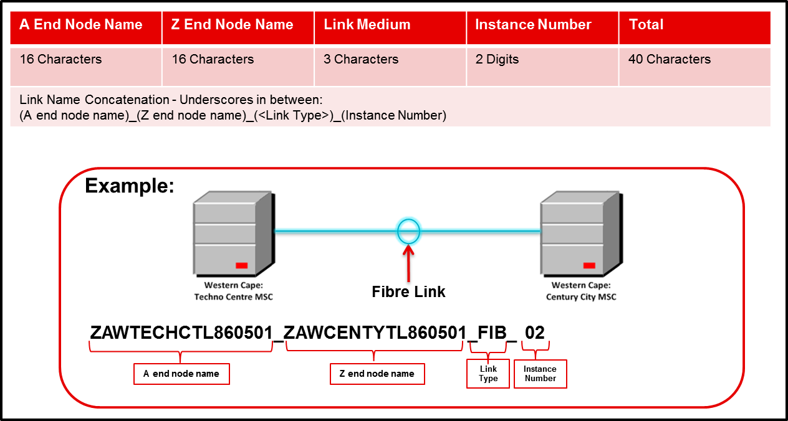
Figure 3 Link Naming Convention

Link Naming Components
The following table gives the Link Naming Components

Link Naming Components | No of Characters | Example
A-end terminating node | 16 Characters | ZAWTECHCTL860501
Z-end terminating node | 16 Characters | ZAWCENTYTL860501
Link Medium | 3 Characters | FIB  Refer section 4.12 Link
Instance Number | 2 Digits | 01
Table 8 Link Naming Components

A-End and Z-End Terminating Nodes Component
User will select the A-end and Z-end sites while generating the link name using the Naming Convention Tool. All the nodes at the selected A-end and Z-end sites will be displayed; user will select the appropriate node at the site.

Link Medium Component
The Link Medium Type will show the medium used between the two nodes. The Link Medium will be a dropdown which the user will select while generating the link name using the Naming Convention Tool. A 3 Character code will be generated for each Link Type. Refer section 4.12 Link for link medium identified with their link codes. Type Code will be automatically generated by the tool while adding the new types as a part of metadata creation

Instance Number Component
The Instance Number will be calculated automatically. The instance number will be incremented per link between two nodes per link type.

Link Attributes
Based on the requirements and data analysis, there are certain components which are captured part of name but can be derived from a relationship or attribute value.

Below are such identified attributes which are required to be filled while generating the new Link name.
Attribute Name | Attribute Type | Character Length | Example
Bandwidth | Mandatory | 5 Characters | 100Mx  Refer section 4.13 Link Bandwidth and Bandwidth Code
Protection Type | Mandatory | Enumeration | Primary  Refer section 4.14 Protection Type
Backup Link Name | Mandatory if “Secondary” protection type is selected | 50 Characters | ZAWTECHCTL860501_ ZAWCENTYTL860501_FIB_10Gxxx_002
Status | Mandatory | Enumeration | In Service  Refer section 4.16 Link Status
Operator Type | Mandatory | Enumeration | Telkom  Refer section 4.15 Link Operator Type
Business Area | Mandatory | Enumeration | Vodacom Business  Refer Section Business Area / Internal Customer
Link Number | Optional | 50 Characters | EML0001290
Physical Trunk Type | NA | NA | Ethernet  Refer section 4.31 This will be included once IMS is in place
Broadband Interface | NA | NA | Electrical  Refer section 4.32 Broadband Interface Type This will be included once IMS is in place
Table 9 Link Attributes

Bandwidth Component
The Bandwidth component will show the bandwidth of the link. User will have an option of selecting either from the Bandwidth available in the dropdown or define a new bandwidth if the required bandwidth value is not present in the list while population the link attributes. Refer section 4.13 Link Bandwidth and Bandwidth Code for the indicative list of bandwidth values currently configured in Vodacom with their bandwidth codes.

Protection Type Attribute
The current Trunk Naming Convention captures whether the Trunk is Primary or Secondary in the Trunk Name. This will now be captured as an attribute to the link. The attribute will be a dropdown which the user will select while generating the link name using the Naming Convention Tool. Refer section 4.14 Protection Type for the Protection values for a Link.

Backup Link Name Attribute
Backup Link Name is required to identify the Primary Secondary link pair. When the Primary link name is generated using the Naming Convention tool, the Secondary link name will be populated in this field and vice versa. The attribute will be supported by a search box which will allow the user to find the backup link.

Status Attribute
Status will be stored as an attribute to the Link. The attribute will be a dropdown which the user will select while generating the Link name using the Naming Convention Tool. Refer section 4.16 Link Status

Operator Type Attribute
Operator Type will be a dropdown which the user will select while generating the Link name using the Naming Convention Tool. Refer section 4.15 Link Operator Type for list of Operator Types

Link Number Attribute
The current Trunk Naming Convention captures the link number generated in TX Manager in the Trunk Name. This will now be captured as an attribute to the link. Link Number will be passed from TX SOM in case of links been requested by TX SOM. In other cases, users will need to fill the Link Numbers manually.

Business Area Attribute
Business Area like VB is captured in the current name. This will now be captured as an attribute to the link. The attribute will be a dropdown which the user will select while generating the link name using the Tool.

Circuit (Logical Link)

Circuit Naming Convention
Below is the proposed naming convention for Circuit.

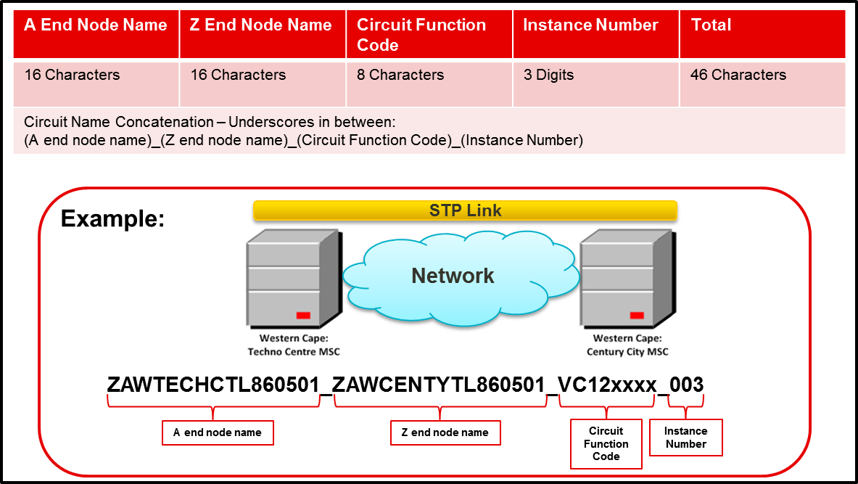
Figure 4 Circuit Naming Convention

Circuit Naming Components
The following table gives the Circuit Naming Components

Link Naming Components | No of Characters | Example
A-end terminating node | 16 Characters | ZAWTECHCTL860501
Z-end terminating node | 16 Characters | ZAWCENTYTL860501
Circuit Function Code | 8 Characters | VC12xxxx  Refer section 4.17 Circuit Function Code
Instance Number | 3 digits | 001
Table 10 Circuit Naming Components

Terminating Nodes Component
User will select the A-end and Z-end sites while generating Circuit name using Naming Convention Tool. All the nodes at the selected A-end and Z-end sites will be displayed; user will select the appropriate node at the site.

Circuit Function Code Component
The Circuit Type will be a component of the Circuit Name. User will select the Circuit Type and corresponding bandwidth type using the Naming Convention Tool. The tool should automatically generate the Circuit Function Code based on the user selection. The Circuit Function Code comprised of two components:
- Circuit Type
- Bandwidth Value (in kbps, mbps or gbps) which is based on user selection of bandwidth and the multiplier value. Each bandwidth type has a corresponding bandwidth value as per standards.
When users select a circuit type where there is no concatenation scenario (no multiplier) defined in the document, tool should not ask for multiplier to users and use the pre-defined function code. Refer the circuit function code table for examples.
The following below sub-sections will describe the various Circuit Types in Transmission, RAN and Mobile core identified from Vodacom Network mapped with Standard Technology and Circuit Types. Type Code will be loaded as prescribed in the document for the existing Circuit Types. Users should be able to define circuit function code while adding the new types as a part of metadata creation

Transmission

Circuits (Logical Link) Type
1/0 VC-12 Trunk
1/0 VC-12-mc Trunk
1/0 VC-2-mc Trunk
4/1 VC4 Trunk
4/1 VC4 Trunk(Ethernet)
4/1 VC-4 External Trunk
1/0 8M Trunk
OCH Trunk
SDH tu12 Circuit
SDH tu12 Circuit (Ethernet)
SDH tu3 Circuit
SDH tu3 Circuit (Ethernet)
SDH tu2 Circuit
SDH tu2 Circuit
(Ethernet)
SDH AU4 Circuit
SDH AU4 Circuit
(Ethernet)
PDH 1/0 Circuit
E-LAN
VLAN
VLAN 802.1Q
VRF (MPLS)
Tunnels
E1 Circuit
P2P Circuit
EVC
EPL
EVPL
PPP Trunk
Frame Relay Trunk
Frame Relay Virtual Circuit
Ethernet
Table 11 Circuit Types for SDH& PDH Transmission & CDN

Below are the various network scenarios identified in Vodacom Transmission Network.

Transmission Circuit Hierarchy
The below diagram is the high level Vodacom South Africa Transmission Network Architecture. Transmission Core Network comprises of Tellabs 7100 DWDM Rings connected with outer Tellabs 6300 and 8800 series of devices to create an aggregate ring. Tellabs 8100 series of nodes creates PDH Ring and 8600 series of access nodes are the serving nodes in Tellabs architecture.

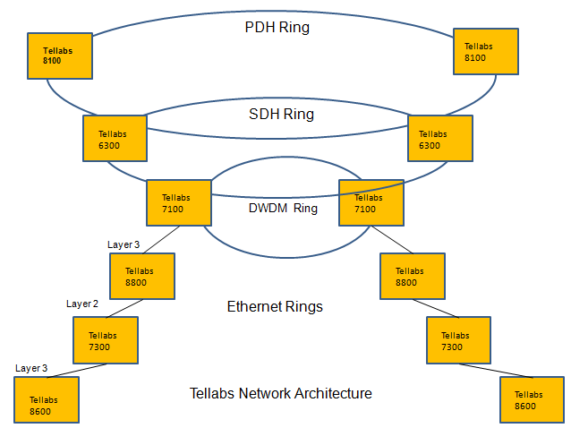
Figure 5 Tellabs Network Architecture

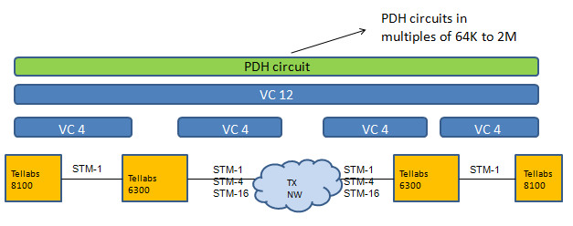
Figure 6 PDH Circuit Hierarchy with STM between 6300 and 8100

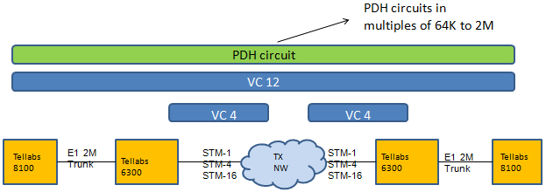
Figure 7 PDH Circuit Hierarchy with E1 between 6300 and 8100

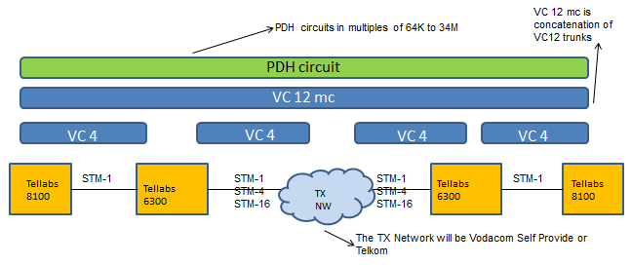
Figure 8 PDH Circuit Hierarchy with Concatenation of VC12’s

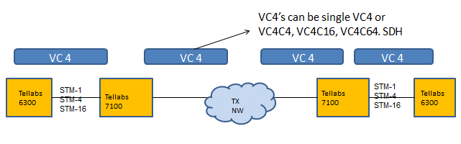
Figure 9 VC4 concatenation scenarios

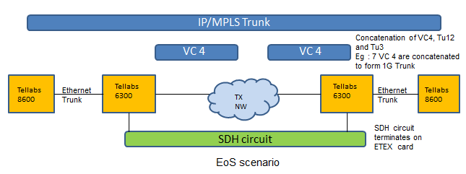
Figure 10 EoS Scenario

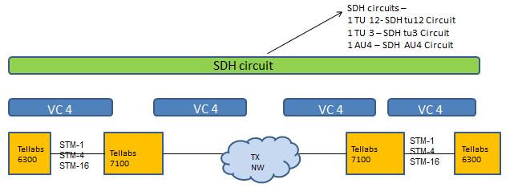
Figure 11 SDH Circuit Hierarchy

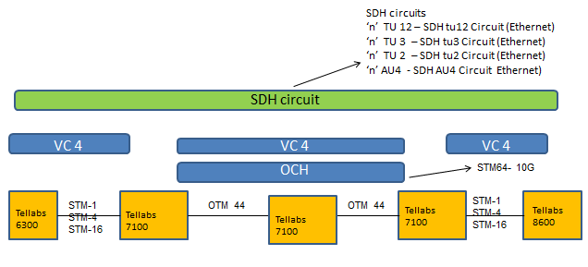

Figure 12 SDH Circuit Hierarchy with Concatenation of TU12, TU3 and AU4

Following table shows the Transmission Ethernet, IP and ATM Logical Circuits mapped to Standard Circuit Types
Logical Link Type
VLAN Trunk
VLAN VPN
ATM_L2VPN
Ethernet L2 VPN
TDM L2 VPN
BGPMPLSVPN
S-VLAN
Pseudowire
IP/MPLS Trunk
Tunnel
Table 12 Circuit Types for IP Transmission & CDN

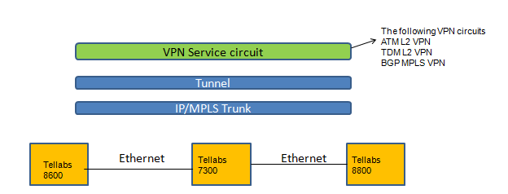
Figure 13 VPN Circuit Hierarchy back

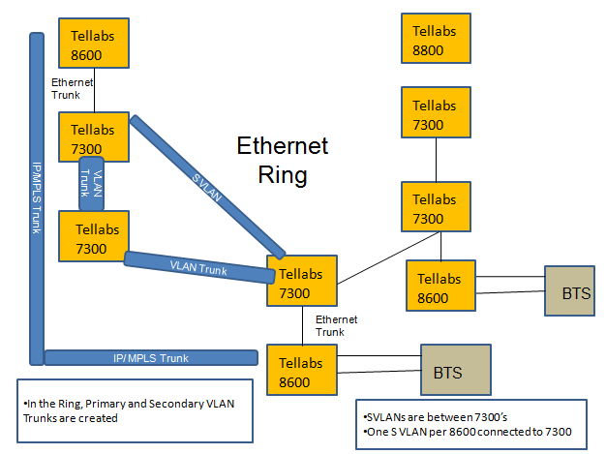
Figure 14 Ethernet Ring

RAN
Following table shows the logical link types in RAN Access segregated based on technology and Vendor. Each table has vendor information, Technology like 2G or 3G, Underlying Technology layer like SDH or IP, Logical Link Type, Mapped Circuit Type and Interface Type. Logical Link Type is mapped with standard Circuit Type which will be used in Naming Convention Tool.

NSN 2G
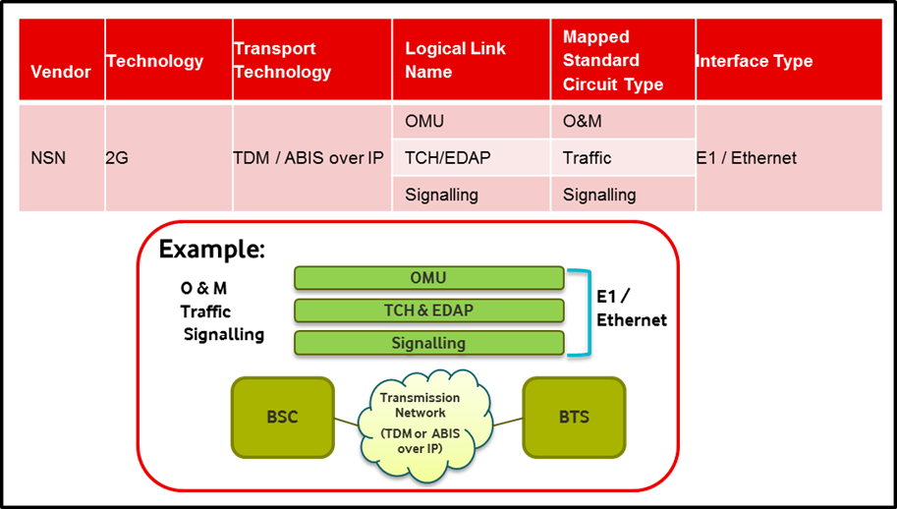
Figure 15 NSN 2G RAN Access Logical Links

NSN 3G
Vendor | Technology | Transport Technology | Logical Link Name | Mapped Standard Circuit Type | Interface Type
NSN | 3G | IP | O&M DCN | O&M | IuB
 |  |  | IPNB | Traffic
 |  | ATM | O&M DCN | O&M
 |  |  | COCO | Traffic
Table 13 NSN 3G RAN Access Logical Links

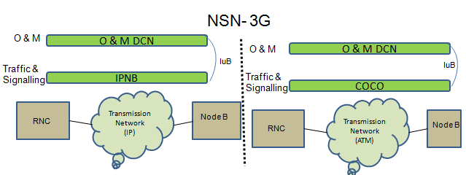
Figure 16 NSN 3G IuB Hierarchy

Huawei 2G

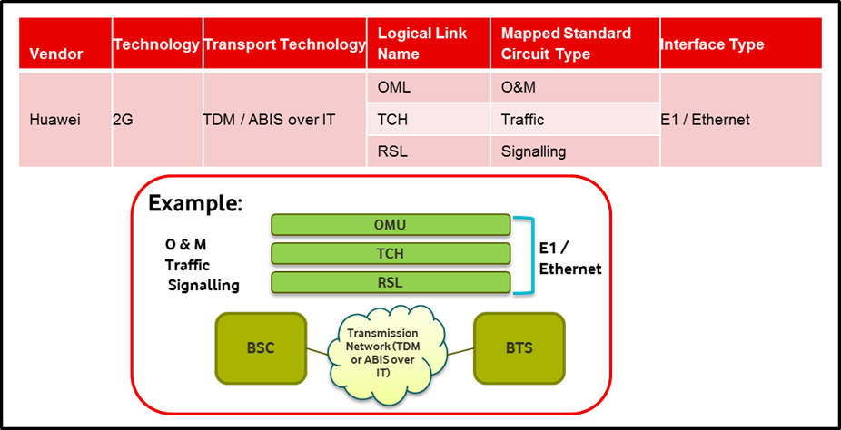
Figure 17 Huawei 2G RAN Access Logical Links

Huawei 3G

Vendor | Technology | Transport Technology | Logical Link Name | Mapped Standard Circuit Type | Interface Type
Huawei | 3G | ATM | IPOA | O&M | IuB
 |  |  | AAL2PATH | Traffic
 |  |  | NCP/CCP/ALCAP | Signalling
 |  | IP | OMCH | O&M
 |  |  | IP PATH | Traffic
 |  |  | SCTP | Signalling
Table 14 Huawei 3G RAN Access Logical Links

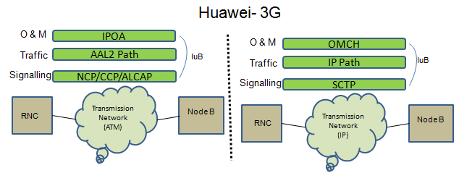
Figure 18 Huawei 3G IuB Hierarchy

CORE
NSN 2G
Vendor | Technology | Transport Technology | Logical Link Name | Mapped Standard Circuit Type | Interface Type
NSN | 2G | SDH | ATER | ATER | ATER
 |  | IP | DATA | Traffic | Gb
 |  |  | M3UA | Signalling
Table 15 NSN 2G RAN Core Logical Links

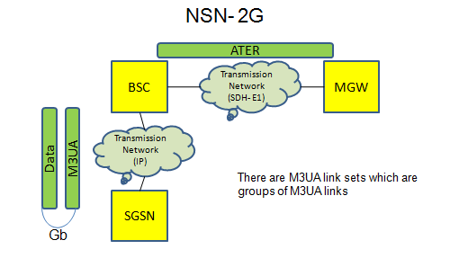
Figure 19 NSN 2G RAN Core Circuit Hierarchy

NSN 3G
Vendor | Technology | Transport Technology | Logical Link Name | Mapped Standard Circuit Type | Interface Type
NSN | 3G | IP | DATA | Traffic | IUPS
 |  |  | M3UA | Signalling
 |  | ATM | DATA | Traffic | IUR
 |  |  | MTP3 | Signalling
 |  |  | DATA | Traffic | IUCS
 |  |  | MTP3 | Signalling
Table 16 NSN 3G RAN Core Logical Links
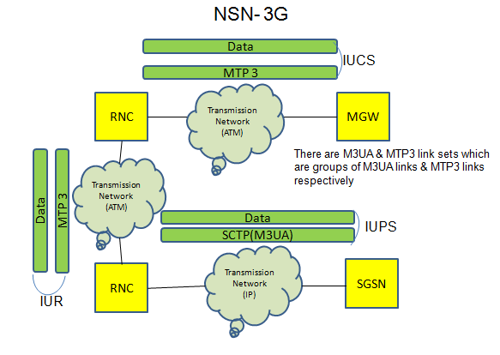
Figure 20 NSN 3G RAN Core Circuit Hierarchy

Huawei 2G
Vendor | Technology | Transport Technology | Logical Link Name | Mapped Standard Circuit Type | Interface Type
Huawei | 2G | SDH | ATER | ATER | ATER
 |  |  | A | A | A
 |  | IP | Gb | Gb | Gb
Table 17 Huawei 2G RAN Core Logical Links

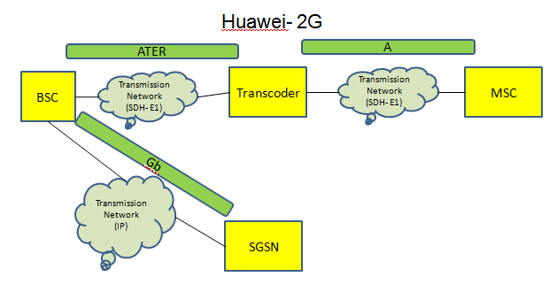
Figure 21 Huawei 2G RAN Core Circuit Hierarchy
Huawei 3G

Vendor | Technology | Transport Technology | Logical Link Name | Mapped Standard Circuit Type | Interface Type
Huawei | 3G | ATM | AAL2 PATH | Traffic | IUCS
 |  |  | MTP3 | Signalling
 |  | IP | IP PATH | Traffic | IUPS
 |  |  | SCTP | Signalling
 |  | ATM | AAL2 PATH | Traffic | IUR
 |  |  | MTP3 | Signalling
Table 18 Huawei 3G RAN Core Logical Links
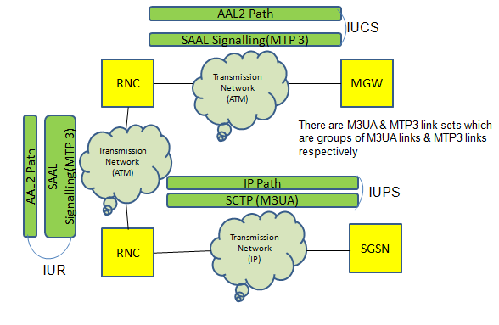
Figure 22 Huawei 3G RAN Core Circuit Hierarchy

The following table shows the Mobile Core logical links.
Logical Link Name
STP
SS7
Trunk Groups
Circuit Group

Table 19 Circuit Types and Circuit Type Code for Mobile Core Logical Links
Following diagrams show the logical connectivity between the Mobile Core devices.
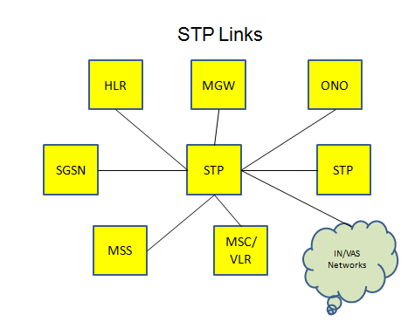
Figure 23 STP Links

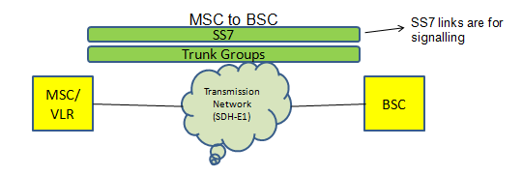
Figure 24 Signalling and Traffic between MSC and BSC

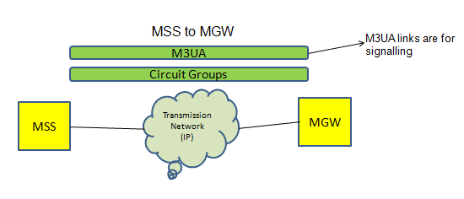
Figure 25 Signalling and Traffic between MSS and MGW

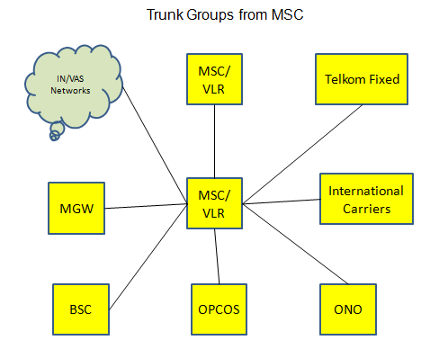
Figure 26 Trunk Groups from MSCs to other Nodes

Instance Number Component
The Instance Number will be calculated automatically. The instance number will be incremented between the two nodes per circuit type.

Circuit Attributes
Based on the requirements and data analysis, there are certain components which are captured part of name but can be derived from a relationship or attribute value.
Below are such identified attributes which are required to be filled while generating the new Circuit name.

Attribute Name | Attribute Type | Character Length | Example
Protection Type | Mandatory | Enumeration | Primary  Refer section 4.14 Protection Type
Backup Circuit Name | Optional, but Mandatory when “Secondary” Protection Type is selected | 50 Characters | ZAWTECHCTL860501_ZAWCENTYTL860501_VC12xxxx_004
Status | Mandatory | Enumeration | Planned  Refer section 4.18 Circuit Status
Circuit Service Type  (This will be applicable to Service Circuit Only) | Optional | Enumeration | ABIS  Refer section 4.19 Circuit Service Type
A-end service node  (This will be applicable to Service Circuit Only) | Optional | 50 Characters | ZAWCENTY HWB69G01  (BSC node connecting to A-end Tellabs)
Z-end service node  (This will be applicable to Service Circuit Only) | Optional | 50 Characters | ZAWTECHC HWB39A01  (BTS node connecting to Z-end Tellabs)
Business Area/ Internal Customer | Mandatory | 3 Characters | EBU etc
Table 20 Circuit Attributes

Protection Type Attribute
The Protection status will be captured as an attribute to the Circuit. The attribute will be a dropdown which the user will select while generating the Circuit name using the Naming Convention Tool. Refer section 4.14 Protection Type

Backup Circuit Name Attribute
Backup Link Circuit is required to identify the Primary Secondary Circuit pair. When the Primary Circuit name is generated using the Naming Convention tool, the Secondary Circuit name will be populated in this field and vice versa. The attribute will be supported by a search box which will allow the user to find the backup link.

Status Attribute
Status will be stored as an attribute to the Circuit. The attribute will be a dropdown which the user will select while generating the Circuit name using the Naming Convention Tool. Refer section 4.18 Circuit Status

Circuit Service Type Attribute
The E2E Tellabs Circuit is used to provide services for RAN and Core Links i. e Signalling, Traffic and O&M. These service types were earlier captured in the circuit names. The Circuit Service Type will be an attribute to the Circuit which will be a dropdown which the user will select while generating the Circuit name using the Naming Convention Tool. Refer section 4.19 Circuit Service Type

Service node Attribute
The current Tellabs Circuits and the MPLS VPNs captures the BTS and BSC codes in the Circuit Name. In the new convention this will be captured as attributes to the Circuit as A-end Service Node and Z-end Service Node. The attribute will be supported by a search box which will allow the user to find the backup link.

This attribute will be applicable to the highest level Tellabs Circuit only.

Business Area / Internal Customer Attribute
Different naming conventions are followed in the circuit as per the Business Area / Internal Customers. The same will be captured as part of the Business Area / Internal Customer attribute for nodes.

Business Area / Internal Customer will appear as a drop down to users when they are generating node name using theTool. Refer Business Area / Internal Customer

Cell

Cell Naming Convention

Below is the proposed naming convention for Cell. New convention for Cell is same as current Cell Naming Convention but since the BTS/Node B naming convention has changed new Cell name will also change.

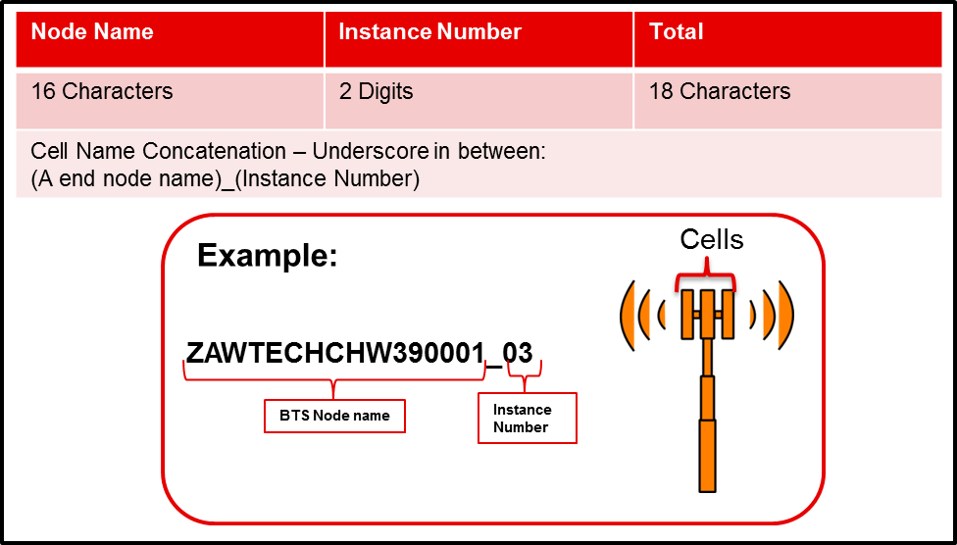

Figure 27 Cell Naming Convention

Cell Attributes

No Attributes defined.

RACK

Rack Naming Convention
Below is the proposed naming convention for Rack.

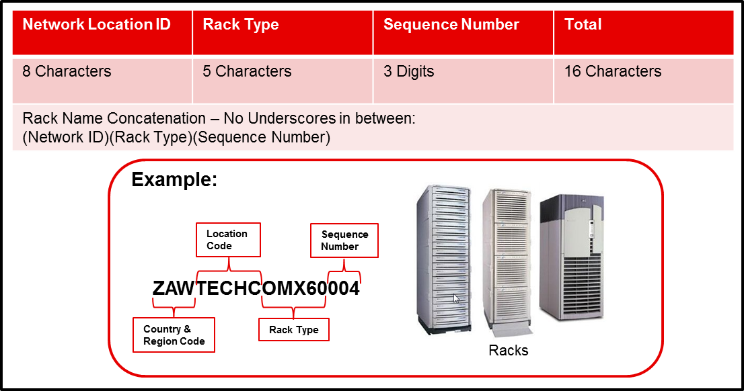
Figure 28 Rack Naming Convention

Rack Naming Components
Naming Components | No of Characters | Example
Country Code | 2 Characters | ZA
Region Code | 1 Character | W
Location Code | 5 Characters | TECHC
Rack Type Code | 5 Characters | OMX60  Refer Table 55 Rack Type List
Instance Number | 3 digits | 004
Table 21 Rack Naming Components

Location Component
User will first select the site where the Rack is to be placed.
The Site will be created as per Table 3 Location Type Relationships
The Country Code, Province Code and the Location Code will be automatically derived from the site selected by the user while generating the Rack name using the Naming Convention Tool.

Rack Type Component
The list of Rack Type will be available as a drop down which the user will select using the Naming Convention tool. Refer Table 55 Rack Type List for Rack Type Codes. Type Code will be automatically generated by the tool while adding the new types as a part of metadata creation. The code provided in appendix is for example.

Instance Number
The Instance Number will be calculated automatically. The instance number will be incremented per rack under a particular location based on Rack Type.

Rack Attributes
Attribute Name | Attribute Type | Character Length | Example
Rack Position | Mandatory | 50 Characters | A:02
Rack Owner | Mandatory | Enumeration | Vodacom  Refer Table 65 Rack Owner
Rack Size | Mandatory | 50 Characters | 72U
Table 22 Rack Attributes

Rack Position Attribute
The current Rack Naming Convention contains the rack position in the name. This component will be stored as an attribute to the rack. The attribute will be a free text box which the user will populate while generating the rack name using the Naming Convention Tool.

Rack Owner
This attribute will capture as to who owns the site i.e. if the site is owned by Vodacom, Telkom, MTN, Cell C, Telkom etc. The attribute will be a drop down which the user will fill while creating a site under a location using the naming convention tool. Refer Table 65 Rack Owner

Rack Size
This component will be stored as an attribute to the rack. The attribute will be a free text box which the user will populate while generating the rack name using the Tool.

ODF / Patch Panel

ODF / Patch Panel Naming Convention
Below is the proposed naming convention for ODF / Patch Panel.
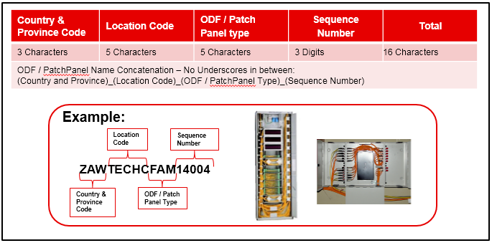
Figure 29 ODF/ Patch Panel Naming Convention

ODF / Patch Panel Naming Components
Naming Components | No of Characters | Example
Country Code | 2 Characters | ZA
Region Code | 1 Character | W
Location Code | 5 Characters | TECHC
ODF / Patch Panel Type Code | 5 Characters | ADCFL  Refer Table 56 ODF Type List
Instance Number | 3 digits | 004
Table 23 ODF / Patch Panel Naming Components

Location Component
User will first select the site where the ODF / Patch Panel is to be placed.
The Site will be created as per Table 3 Location Type Relationships. The Country Code, Province Code and the Location Code will be automatically derived from the site selected by the user while generating the ODF / Patch Panel name using the Naming Convention Tool.

ODF / Patch Panel Type Component
The list of ODF / Patch Panel Type will be available as a drop down which the user will select using the Naming Convention tool. Refer Table 56 ODF / Patch Panel Type List for list of ODF / Patch Panel Types and Codes. Type Code will be automatically generated by the tool while adding the new types as a part of metadata creation. The code provided in appendix is for example.

Instance Number
The Instance Number will be calculated automatically. The instance number will be incremented per rack under a particular location based on ODF / Patch Panel Type.

ODF / Patch Panel Attributes
Attribute Name | Attribute Type | Character Length | Example
ODF / Patch Panel Position | Mandatory | 50 Characters | A:02
Manhole Entry | Mandatory | 100 Characters | WGEOVM0001
Table 24 ODF / Patch Panel Attributes

ODF / Patch Panel Position Attribute
The current ODF / Patch Panel Naming Convention contains the ODF / Patch Panel position in the name. This component will be stored as an attribute to the ODF / Patch Panel. The attribute will be a free text box which the user will populate while generating the ODF / Patch Panel name using the Naming Convention Tool.

Manhole Entry Attribute
The attribute will be supported by a search box which will allow the user to find the backup link.

ODF / Patch Panel Port

ODF / Patch Panel Port Naming Convention
Below is the naming convention for ODF / Patch Panel Port currently implemented in Connect Master and will be used as-is.
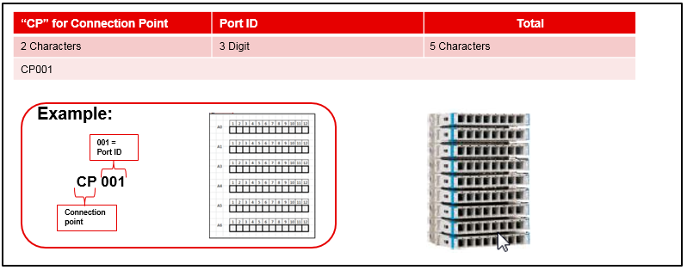
Figure 30 ODF / Patch Panel Port

ODF / Patch Panel Port Naming Components
Naming Components | No of Characters | Example
Connection Point | 2 Characters | CP
Port Number | 3 Number | 001
Table 25 ODF / Patch Panel Port Naming Components

Connection Point Component
This will be generated by Connect Master automatically while creating an ODF/ ODR/ Patch Panel etc.

Port ID Component
This will be generated by Connect Master automatically while creating an ODF/ ODR/ Patch Panel etc.

ODF / Patch Panel Port Attributes
Attribute Name | Attribute Type | Character Length | Example
Bar Code | Optional | 10 Characters | AAA 440
Table 24 ODF / Patch Panel Port Attributes

Bar Code Attribute
This attribute will be captured by another project to detect the connectivity between two ports of ISP devices.

Device Port (For ISP)

Device Port Naming Convention
Below is the proposed naming convention for Device Port for ISP labelling. The naming will be as per current implementation of Connect Master.
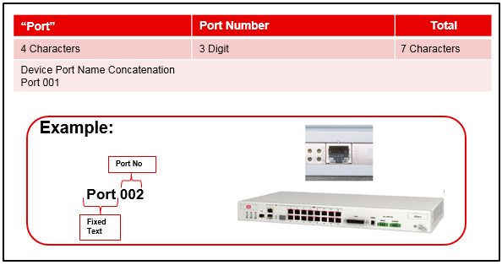
Figure 32 Device Port Naming Convention

Device Port Naming Components
Naming Components | No of Characters | Example
Port | 4 Characters | Port
Port Number | 3 Characters (Numeric only) | 001
Table 26 Device Port Naming Components

Port Component
Port will be a text prefix to ports of device.

Port Number Component
Port number will be auto allocated while creating an active device in Connect Master.

Device Port Attributes
Attribute Name | Attribute Type | Character Length | Example
Bar Code | Optional | 10 Characters | AAA 440
Table 24 ODF Port Attributes

Bar Code Attribute
This attribute will be captured by another project to detect the connectivity between two ports of ISP devices (ODF/ODR/Patch Panel/Active Equipment etc.).

Patch Cord

Patch Cord Naming Convention
Below is the proposed naming convention for Patch Cord.
Note: Kindly note that currently patch cord are not modelled in Connect Master and the below convention will be implemented once the modelling is available in Connect Master.
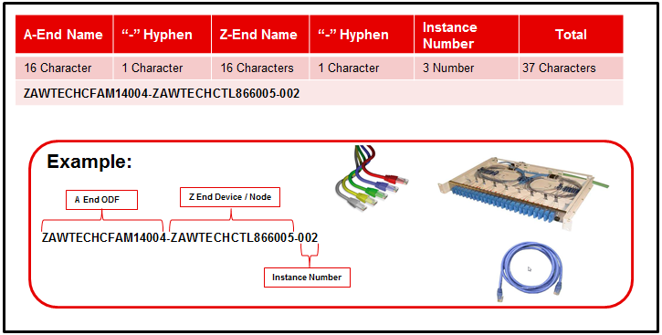
Figure 34 Patch Cord/Cable/Lead Naming Convention

Patch Cord Naming Components
Naming Components | No of Characters | Example
A/Z End ODF Name | 16 Character | ZAWTECHCFAM14004
A/Z End Device Name | 16 Characters | ZAWTECHCTL860005
Instance Number | 3 Number | 002
Table 27 Patch Cord Naming Components

A/Z End ODF and Device Name Component
This will be the starting or terminating ODF/ODR/PP/Active equipment name for the patch cord/lead.

Instance Number
This will be the instance number of patch cord/lead within the originating and terminating devices.

Patch Cord Attributes
Attribute Name | Attribute Type | Character Length | Example
Link Number: WL | Optional (when available) | 10 Characters | Link Number: WL (WL00000034) for Wire Links as ordered within Transmission domain

Link Number
The current Trunk Naming Convention captures the link number generated in TX Manager in the Trunk Name. This can also be captured as an attribute to the Patch Cord where it was allocated within the Transmission domain. The attribute will be a free text which the user will populate while generating the link name using the Naming Convention Tool.

Manhole

Manhole Naming Convention
Below is the proposed naming convention for Manhole for OSP labelling.

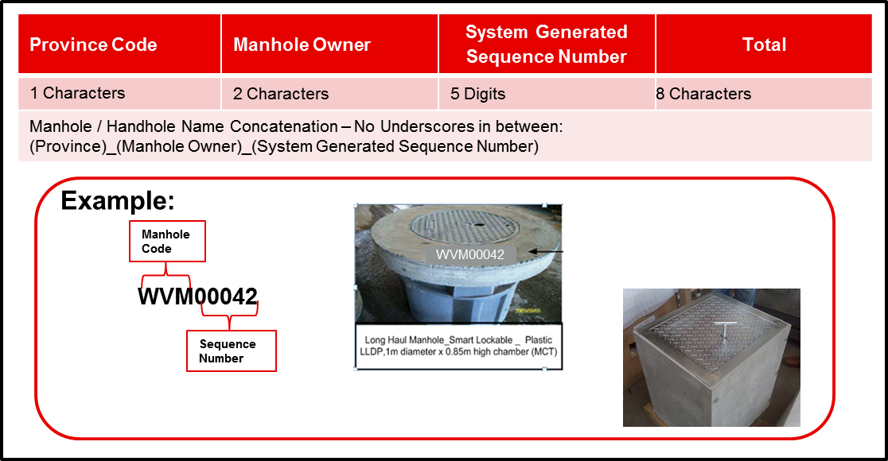
Figure 34 Manhole Naming Convention

Manhole Naming Components
Naming Components | No of Characters | Example
Province Code | 1 Character | W
Manhole Owner | 2 Character | VM for Vodacom Manhole or Handhole
Instance Number | 5 Digits | 00042
Table 30 Manhole Naming Components

Province ID Component
Users will be provided with an option to select a Province ID to generate a new Manhole name. The manhole name will have Province as the first character.

Manhole Owner Component
Once user selects appropriate Country and province to generate a manhole name, they also need to select appropriate Manhole Owner. Manhole owner would be Vodacom, Telkom etc. Each manhole owner will be referred in the name with unique ID. The list of ID for each owner can be found in Table in appendix.

Instance Number Component
Instance number will be generated for each manhole sequentially and not based on the province selected. This instance number will be a 5 digit number and will be unique.

Manhole Attributes
Attribute Name | Attribute Type | Character Length | Example
Latitude | Mandatory | Number | -26.161997
Longitude | Mandatory | Number | 28.210252
Complete Address | Optional (if available) | 250 Characters | 12 Bussing Road, Aureus,  Randfontein
Manhole Type | Mandatory | Drop Down | Draw box (600 x 600 x1000)  Refer Table 66 Manhole Type List
Manhole Number | Mandatory | Free Text box
Table 31 Rack Attributes

Latitude, Longitude and Complete Address Attribute
User needs to capture this attribute while generating manhole name. This attribute will enrich the manhole position information and will help field engineers to locate manhole position in case of any fault or any changes in network.

Manhole Types
User needs to capture this attribute while generating manhole name. This attribute will ensure the manhole type and thus will help in space reservations and planning. Refer Table 66 Manhole Type List

Manhole Number
User needs to capture this attribute while generating manhole name. This attribute will be useful to unlock the manhole.

Pole for Overhead Fibre

Pole Naming Convention
Below is the proposed naming convention for Poles for OSP labelling.
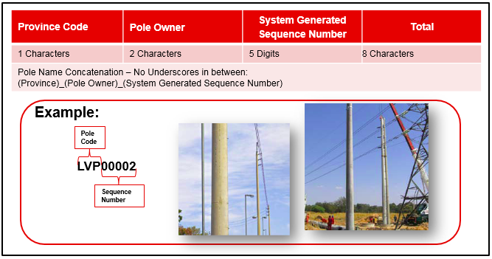

Pole Naming Components
Naming Components | No of Characters | Example
Province Code | 1 Character | L for Limpopo Province
Manhole Owner | 2 Character | VP for Vodacom Pole
Instance Number | 5 Digits | 00002
Table 32 Manhole Naming Components

Province ID Component
Users will be provided with an option to select a Province ID to generate a new Pole name. The Pole name will have province as the first character.

Pole Owner Component
Once user selects appropriate Province to generate a Pole name, they also need to select appropriate Pole Owner. Pole owner would be Vodacom, Telkom etc. Each Pole owner will be referred in the name with unique ID. The list of ID for each owner can be found in the Table in appendix.

Instance Number Component
Instance number will be generated for each Pole sequentially and not based on the province selected. This instance number will be a 5 digit number and will be unique.

Pole Attributes
Attribute Name | Attribute Type | Character Length | Example
Latitude | Mandatory | Number | -26.161997
Longitude | Mandatory | Number | 28.210252
Complete Address | Optional (if available) | 250 Characters | 12 Bussing Road, Aureus,  Randfontein
Pole Manufacturer | Mandatory | Drop Down | Rocla  Aveng  Refer Table 74 Pole Manufacturer and Specification List
Pole Specification | Mandatory | Drop Down linked to the Manufacturer field | 9m Hollow from Rocla 5,5kn  9m cast pole from Rocla 4kn  Refer Table 74 Manhole Type List
Table 29 Rack Attributes

Latitude, Longitude and Complete Address Attribute
User needs to capture this attribute while generating Pole name. This attribute will enrich the Pole position information and will help field engineers to locate Pole position in case of any fault or any changes in network.

Pole Types
User needs to capture this attribute while generating Pole name. This attribute will ensure the Pole type and thus will help in space reservations and planning. Refer Table 66 Pole Type List

Pole Specification
User needs to capture this attribute while generating Pole name. This attribute will be useful for inventory management. Refer Table 66 Pole Type List

Splice Closure

Splice Closure Naming Convention
There are two types of Splice Closure:
- Overlying: A splice Closure on Pole.
- Underlying: A splice Closure inside manhole.
Below is the proposed naming convention for splice closure for OSP labelling.

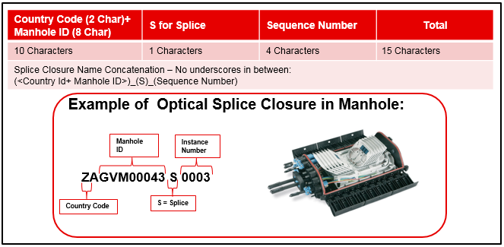
Figure 36a Manhole Splice Closure Naming Convention

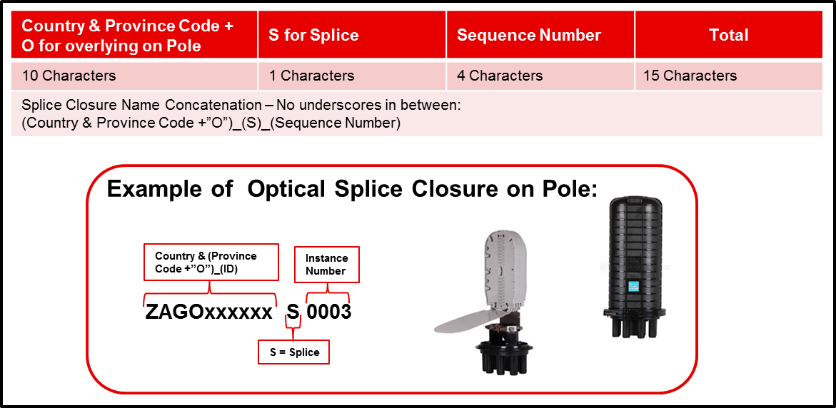
Figure 36b Overlying Splice Closure on Pole Naming Convention

Splice Closure Naming Components
Naming Components | No of Characters | Example
1) Manhole Id (In case of Underlying)  2) Country & Province plus O (In case of Overlying) | 1) 10 Char in case of Manhole ID.  2) 4 Char Code. Country and Province Code plus an <O> for overlying Splice Closure Code. | ZAGVM0001  ZAGOxxxxxx
<S>Instance Number | 5 Character | S0001
Table 30 Splice Closure Naming Components

Country Code and Manhole ID or Province and Sub Place ID Component
Users will be provided with an option to select the Country and Province and type of Splice Closure to generate a new splice closure name. He will be provided with an option to select manhole name in case of splice closure located inside manhole. The splice closure name will have the country and province as the first 3 characters with manhole number in case of splice closure inside manhole or ‘x’ as a filler to make the component of 10 characters

Instance Number Component
Instance number will be generated for each splice closure based on the province selected. This instance number will be a 4 digit number and will be unique within the province selected.’ S’ will be appended to instance number to make to a splice closure instance number.

Splice Closure Attributes
Attribute Name | Attribute Type | Character Length | Example
Latitude | Mandatory | Number | -26.161997
Longitude | Mandatory | Number | 28.210252
Complete Address | Mandatory | 250 Characters | 12 Bussing Road, Aureus,  Randfontein
Pole Name | Mandatory | 50 Characters | LVP00002
Table 31 Splice Closure Attributes

Latitude, Longitude and Complete Address Attribute
User needs to capture this attribute while generating the Pole name. This attribute will enrich the Pole position information and will help field engineers to locate the Pole position in case of any fault or any changes in network.

Pole Name Attribute
User needs to select this attribute from the existing pole names, while generating splice closure name. This attribute will enrich the splice closure position information and will help field engineers to locate splice closure position in case of any fault or any changes in network.

Duct

Duct Naming Convention
Below is the proposed naming convention for the duct for OSP labelling. Duct labelling will only be required for Vodacom owned ducts. Leased fibre will not carry this information.
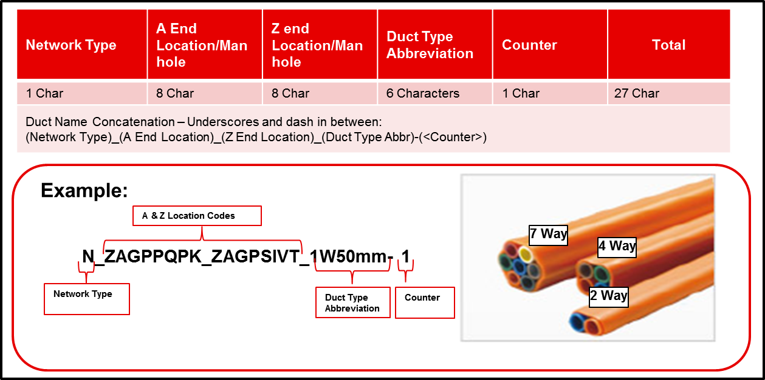
Figure 35 Duct Naming Convention

Duct Naming Components
Naming Components | No of Characters | Example
Network Type | 1 Character | N or C etc Network Type Code List
A-End and Z-End Locations Codes | 8 Characters each | ZAGTECHP
Duct Type Abbreviation | 6 Characters | Duct Type
Duct Counter | 1 Character | 1, 2, etc
Table 32 Cable Naming Components

Network Type Component
This component explains whether the cable is a National Cable or a Core Cable. Users’ needs to select one of the values from a list of values to provide the network type for Cable.

A-End and Z-End Component
Users will be provided to select A-End Site, A-End Type (like ODF, Manhole and Splice Closure) and then A-End Point. The same needs to be done for Z-End. These A-End and Z-End will be part of Cable name.

Duct Type Component
Users will be provided with a list of duct types to select appropriate duct for the trench for which name needs to be generated. For existing Duct Types, the codes will be loaded as prescribed in the document. Type Code will be automatically generated by the tool while adding the new types as a part of metadata creation. List of Duct types which will be provided to users are listed in appendix section. Duct Type.

Duct Counter
Duct between the same A-end and Z-End locations will be numbered as 1, 2 and so on. This number will be generated for each additional Duct of the same type based on the A-End and Z-End selected. This Duct number will be a 1 Character and will be unique within the same two terminating points.

Duct Attributes
Attribute Name | Attribute Type | Character Length | Example
Civil Works Contractor | Mandatory | Enumerations | MCT  Civil works/Fibre Build Contractor List
Route Request Type | Mandatory | Enumerations | Self-Build (SB)  Refer Table 63 Cable Request Type
Table 33 Splice Closure Attributes

Civil Works Contractor Attribute
This attribute is related to the Vendor which were involved in the civil work. It is important to label the duct in an intuitive manner in case there are faults reported. User needs to capture this attribute while generating Duct Name. This is going to be a one of the list of values and will be mandatory attribute to store information. Refer Civil works/Fibre Build Contractor List

Route Request Type Attribute
This attribute is related to the information regarding the ownership of the route in case of faults. Values like SB for Self Build, CB for Co-Build or VCW for Civil Builds will be available for users to select one of them. Refer Table 63 Cable Request Type

Trench

Trench Route Naming Convention

Below is the proposed naming convention for the trench route for ConnectMaster names and OSP labelling. Trench labelling will only be required for fibre routes (Vodacom owned and co-build trenches). Trench route will be group of Trench Sectors showing the actual route. Trenches are named in trench sectors from manhole to manhole.

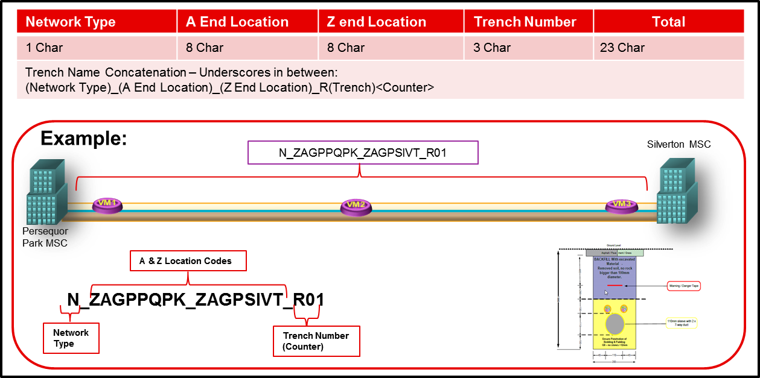
Figure 36 Trench Route Naming

Trench Route Naming Components
Naming Components | No of Characters | Example
Network Type | 1 Character | N or C etc (Table)
Route A-End Location Codes | 8 Characters | ZAGPPQPK
Route Z-End Location Codes | 8 Characters | ZAGPSIVT
Trench Number (Counter) | 2 Characters | T1, T2,……
Table 34 Trench Naming Components

Network Type Component
This component explains whether the cable is a National Cable or a Core Cable. Users’ needs to select one of the values from a list of values to provide the network type for Cable.

A-End and Z-End Locations of Route Component
Users will be provided to select A-End Location and a Z-end location to identify the parent route. Then they have to select the location where the trench started to the first manhole, this must continue from manhole to manhole until the Z-end location of the route are selected.

Trench Number (Counter) Component
Trenches between the same A-end and Z-End locations will be numbered as R01, R02 and so on. This number will be generated for each additional trench based on the A-End and Z-End selected. This Trench number will be a 1 Character + 2 digit number and will be unique within the same two terminating points.

Trench Attributes
Attribute Name | Attribute Type | Character Length | Example
Location / Manhole Latitude | Automated when selected | Number | -26.161997
Location / Manhole Longitude | Automated when selected | Number | 28.210252
Civil Works Contractor | Mandatory | Enumerations | MCT  Civil works/Fibre Build Contractor List
Route Request Type | Mandatory | Enumerations | Self-Build (SB)  Refer Table 63 Cable Request Type
Table 35 Splice Closure Attributes

Latitude and Longitude Attribute
User needs to capture this attribute while generating the Pole name. This attribute will enrich the Pole position information and will help field engineers to locate the Pole position in case of any fault or any changes in network.

Civil Works Contractor Attribute
This attribute is related to the Vendor which were involved in the civil work. It is important to label the trench in an intuitive manner in case there are faults reported. User needs to capture this attribute while generating Trench Name. This is going to be a one of the list of values and will be mandatory attribute to store information. Refer Civil works/Fibre Build Contractor List Error! Reference source not found.

Route Request Type Attribute
This attribute is related to the information regarding the ownership of the route in case of faults. Values like SB for Self Build, CB for Co-Build or VCW for Civil Builds will be available for users to select one of them. Refer Table 63 Cable Request Type

Trench Sector Naming Convention

Below is the proposed naming convention for the trench for ConnectMaster names and OSP labelling. Trench labelling will only be required for fibre routes (Vodacom owned, co-build and leased trenches). Trenches are named in trench sectors from manhole to manhole.
Trench Sector will be child of Trench route in Connect Master

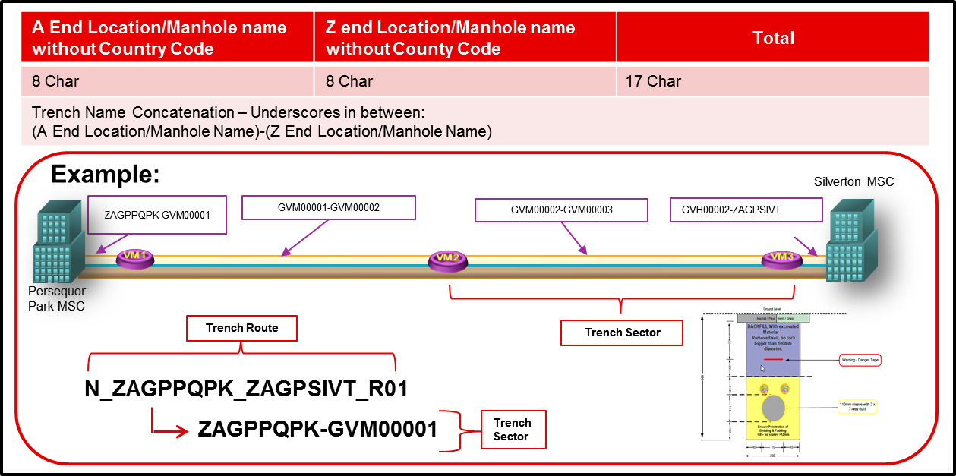
Figure 37 Trench Sector Naming Convention

Trench Sector Naming Components
Naming Components | No of Characters | Example
Start Manhole/Location Codes | 8 Characters | ZAGPPQPK
End Manhole/Location Codes | 8 Characters | ZAGPSIVT
Table 34 Trench Naming Components

Trench Start Component (Manhole/Location)
Users will have to select the trench start Location and the first manhole, this is seen as the trench child route which belongs to the parent route. The child sections of the route are captured from manhole to manhole until the Z-end location has been reached. This naming capability currently exists in TxMan and is created during the capturing of routes on the map (GEO interface).

Trench End Component (Manhole/Location)
Users will have to select the trench start Location and the first manhole, this is seen as the trench child route which belongs to the parent route. The child sections of the route are captured from manhole to manhole until the Z-end location has been reached. This naming capability currently exists in TxMan and is created during the capturing of routes on the map (GEO interface).

Cable

Cable Naming Convention
Below is the proposed naming convention for cable for OSP labelling.

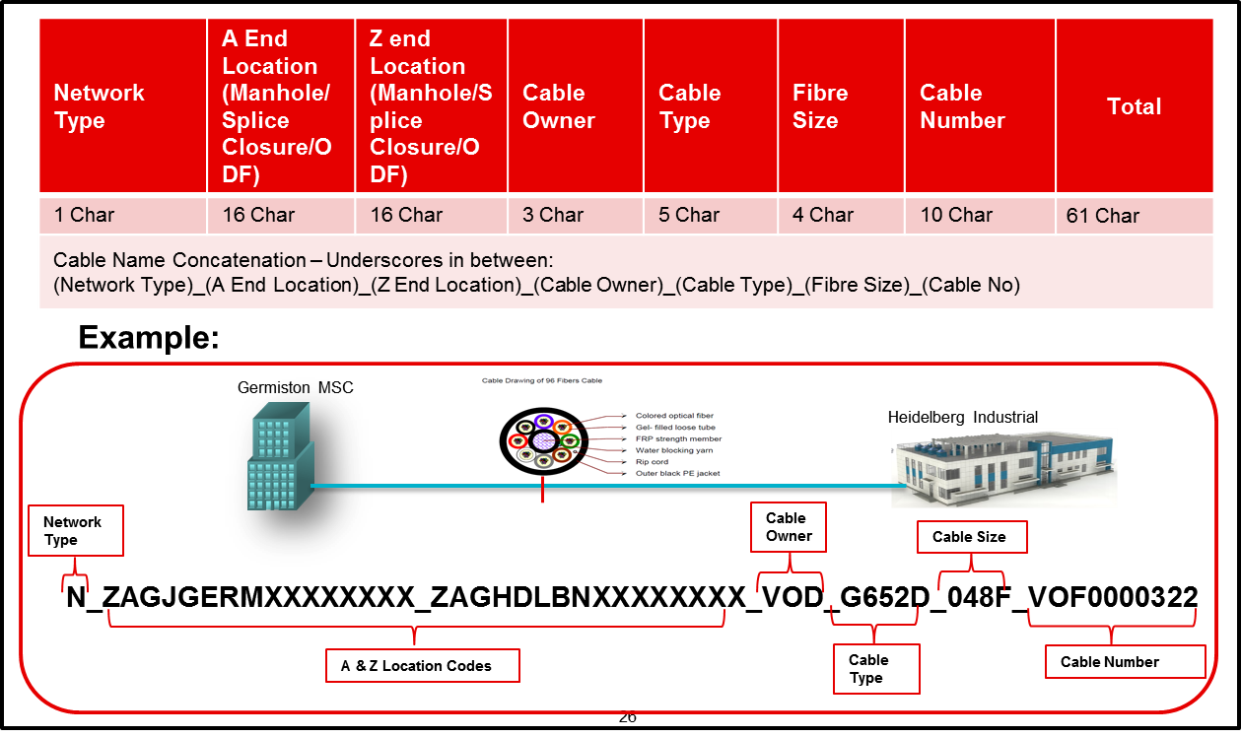
Figure 38 Cable Naming Convention

Cable Naming Components
Naming Components | No of Characters | Example
Network Type | 1 Character | N or C etcNetwork Type Code List
A-End and Z-End Locations | 16 Characters each | ZAGTECHPXXXXXXXX
Cable Owner | 3 Characters | VOD / DFA etc
Cable Type | 5 Characters | G652D  Refer Table 57 Cable Type List
Cable (Fibre) Size | 4 Characters | 024F  Refer Table 60 Fibre Size List
VOF, WL or CL | 10 Characters | VOF0000322
Table 36 Cable Naming Components

Network Type Component
This component explains whether the cable is a National Cable or a Core Cable. Users’ needs to select one of the values from a list of values to provide the network type for Cable.

A-End and Z-End Component
Users will be provided to select A-End Site, A-End Type (which can be one of the following: ODF, Manhole, Splice Closure and Nodes) and then A-End Point. The same needs to be done for Z-End. These A-End and Z-End will be part of Cable name.

Cable Owner Component
Users will be provided with a list of cable owners to select appropriate cable owner for the cable for which name needs to be generated. List of cable owners which will be provided to users are listed in appendix section. Cable Owner List

Cable Type Component
Users will be provided with a list of cable types to select appropriate cable type for the cable for which name needs to be generated. For existing Cables Types, the codes will be loaded as prescribed in the document. Type Code will be automatically generated by the tool while adding the new types as a part of metadata creation. List of cable type which will be provided to users are listed in appendix section. Refer Table 57 Cable Type List

Fibre Size Component
Users will be provided with a list of Fibre Sizes to select appropriate Fibre Size for the cable for which name needs to be generated. List of Fibre Size which will be provided to users are listed in appendix section. Refer Table 60 Fibre Size List

Instance Number Component
Instance number will be generated for each Cable based on the A-End and Z-End selected. This instance number will be a 3 digit number and will be unique within the same two terminating points.

Cable (Link) Number Component
This cable number is related to the Link Number (VOF Number) which gets generated in TX Manager for order purpose. This is going to be help in identifying the relationship between the various impacted circuit and the fibre cut using this Link Number. Note that we can harvest the same information using the relationship of Link to Circuit in various other tools.

Cable Attributes
Attribute Name | Attribute Type | Character Length | Example
Cable Provider | Mandatory | Enumerations | Dark Fibre Africa (DFA)  Civil works/Fibre Build Contractor List  Error! Reference source not found.
Cable Request Type | Mandatory | Enumerations | Self-Build (SB)  Refer Table 63 Cable Request Type
Cable Position | Mandatory | Enumerations | Overlying (O)  Underlying (L)
Cable Manufacturer | Mandatory | Enumerations | Samsung  Refer Table 58 Cable Supplier List
Business Area / Internal Customer | Mandatory | 3 Characters | Enterprise Business Unit  Refer Civil works/Fibre Build Contractor List
Table 37 Splice Closure Attributes

Cable Provider Attribute
This attribute is related to the Vendor which provided the cable. In case of any fault in that cable, the cable provided should be contacted. User needs to capture this attribute while generating Cable Name. This is going to be a one of the list of values and will be mandatory attribute to store information. Refer Civil works/Fibre Build Contractor List

Cable Request Type Attribute
This attribute is related to the information regarding the ownership of cable in case of faults. Values like SB for Self Build, CB for Co-Build will be available for users to select one of them. Refer Table 63 Cable Request Type

Cable Position Attribute
This attributes stores the information like cable is an Overlying or Underlying cable. This will help in localising the fault. Only two values will be part of this attribute as Overlying and Underlying.

Cable Manufacturer Attribute
This attribute stores the information like cable is manufactured by Samsung or any other company. Refer Table 58 Cable Supplier List

Business Area / Internal Customer
The Cable naming convention need to include the Business Area / Internal Customers.
Business Area / Internal Customer will appear as a drop down to users when they are generating the cable name using the Naming Convention Tool. Refer Business Area / Internal Customer

References

Naming Convention Tool
The Naming Convention Tool will be used as a centralised tool by all the Network Business User Groups for generation of network object names. The names will be generated as per the convention given in Section 2 Design .

A Naming Convention Tool that was intended to create and maintain the names as defined within this document has been developed. This tool is deemed cumbersome since it:
- Requires that an additional tool is used
- Requires data to be copied into it
- Requires data to be copied back into existing tools used in process

It has been decided that the Naming Convention be implemented in ConnectMaster for the time being. The naming convention & algorithms defined in this document will be implemented.

Appendix

Country Code
Country | Country Code
South Africa | ZA
Tanzania | TZ
Lesotho | LS
DRC | CG
Mozambique | MZ
Table 43 Country Code _Country_Attributes

ZA Province Code
Province Name | Province Code
Gauteng | G
North West | N
Northern Cape | C
Free State | F
Western Cape | W
Mpumalanga | M
Limpopo | L
Eastern Cape | E
Kwazulu Natal | K
Table 44 Province Code _Province_Attributes

LS Province (District) Code
Province Name | Province Code
Berea | B
Butha-Buthe | U
Leribe | L
Mafeteng | M
Maseru | A
Mohale’s Hoek | O
Mokhotlong | K
Qacha’s Nek | Q
Quthing | H
Thaba-Tseka | T
Table 44 Province Code _ LS Province (District)_Attributes

Power Grid Area

Province Name
Caledon Area
Mankweng Area
Hazyview Area
Mossel Bay n Plett Area
Nelspruit Area
Humansdorp Area
George Area
Randburg Area
Midrand Area
Tlokweng Area
Soshanguve Area
Porterville Area
Ga_Rankuwa Area
Glengarry Area
Phokwane Area
Mafikeng Area
Warmbaths Area
Chatsworth Area
Irene Area
Mokopane Area
Citrusdal Area
Diswilmar Area
Eshowe Area
Hlabisa Area
Brooklyn Area
Bethlehem Area
Lynnwood Area
Karoo Area
Thohoyandou Area

Table 44 Power Grid Areas

Location Code Generation Algorithm
The following algorithm will be used to generate the Location Codebased on a Location Name provided. The algorithm will ensure that the Location Code generated remains unique within each Province.
- <First Character > <Second Character> <Third Character> <Fourth Character> <Fifth Character> - “ ABCDE”
- <First Character > <Second Character> <Third Character> <Fourth Character> <Sixth Character> - “ ABCDF”
- <First Character > <Second Character> <Third Character> <Fourth Character> <Seventh Character> - “ ABCDG”
- <First Character > <Second Character> <Third Character> <Fifth Character> <Sixth Character> - “ ABCEF”
- <First Character > <Second Character> <Third Character> < Sixth Character> <Seventh Character> - “ ABCFG”
- <First Character > <Second Character> <Third Character> < Seventh Character> <Eighth Character> - “ABCGH”
- <First Character > <Third Character> <Second Character> <Fourth Character> <Fifth Character> - “ ACBDE”
- <First Character > <Third Character> <Fourth Character> <Fifth Character> <Sixth Character> - “ ACDEF”
- <First Character > <Third Character> <Fourth Character> <Fifth Character> <Second Character> - “ ACDEB”
- <First Character > <Fourth Character> <Second Character> <Third Character> <Fifth Character> - “ ADBCE”
- <First Character > <Fourth Character> <Second Character> <Third Character> <Sixth Character> - “ ADBCF”
- <First Character > <Fourth Character> <Third Character> <Second Character> <Sixth Character> - “ ADCBF”
- <First Character > <Fourth Character> <Third Character> <Second Character> <Fifth Character> - “ ADCBE”
- <First Character > <Fifth Character> <Fourth Character> <Third Character> <Second Character> - “ AEDCB”
- <First Character > <Fifth Character> <Fourth Character> <Second Character> <Third Character> - “ AEDBC”
- <First Character > <Sixth Character> <Fifth Character> <Fourth Character> <Third Character> - “ AFEDC”
- <First Character > <Sixth Character> <Fifth Character> <Second Character> <Third Character> - “ AFEBC”
- <First Character > <Seventh Character> <Sixth Character> <Fifth Character> <Fourth Character> - “ AGFED”
- <First Character > <Seventh Character> <Sixth Character> <Fifth Character> <Third Character> - “ AGFEC”
- <First Character > <Seventh Character> <Sixth Character> <Fifth Character> <Second Character> - “ AGFEB”
- <First Character > <Second Character> <Third Character> <Fourth Character> < Numeric Number (1 to 9)> – “ABCD1”
- <First Character > <Third Character> <Fourth Character> <Fifth Character> < Numeric Number (1 to 9)> - “ ACDE1”
- <First Character > <Second Character> <Third Character> <Fifth Character> < Numeric Number (1 to 9)> - “ ABCE1”
- <First Character > <Second Character> <Third Character> <Two digit Numeric Number ( 01 to 99 )> - “ ABC01”
- <First Character > <Second Character> <Fourth Character> <Two digit Numeric Number ( 01 to 99 )> - “ ABD01”
- <First Character > <Third Character> <Fourth Character> <Two digit Numeric Number ( 01 to 99 )> - “ ACD01”

- For location name with TWO words:

- The first three characters from the first word will be concatenated with the second word,
- Then the first 5 characters of this result will then be sent through the “attempts” as specified above.

Example

Techno Centre

- TEC + CENTRE = TECCENTRE

- TECCE sent through algorithm

- For location name with MORE than TWO words:

- The first two characters from the first word will be concatenated with the second word,
- Then the first 3 characters of this result will be concatenated with the third word,
- Then the first 5 characters of this result will then be sent through the “attempts” as specified above.

Example

Techno Mamparra Centre

a) TE + MAMPARRA = TEMAMPARRA
b) TEM + CENTRE = TE
c) TEMCE sent through algorithm

Type of site
Type of Site
Core
Edge
Aggregation
Access
Hubstation
Table 45 Type of Site

Site Owner
Site Owner
Vodacom
Telkom
MTN
Cell C
Neotel
Fiberco
Teraco
Internet Solutions
Table 46 Site Owner

Vodacom Operating Region
Operating Region | Abbreviation
Central | CEN
Eastern | EAS
Kwazulu-Natal | KZN
Limpopo | LIM
Mpumalanga | MPU
Northern Gauteng | NGA
Southern Gauteng Central | SGC
Southern Gauteng South | SGS
Western | WES
Table 47 Operating Region

POC Type
POC Type
POC 1
POC 2
POC 3
POC 4 (Tail)
Table 43 POC Type for Site

Node / Device Type Code

Vendor | Vendor Mode | Code
Alcatel-Lucent | ULS | ALxULS
Alcatel-Lucent | DWDM 1830PSS-36 | ALPS36
Alcatel-Lucent | DWDM 1830PSS-32 | ALPS32
Alcatel-Lucent | DWDM 1830PSS-64 | ALPS64
Alteon | Alteon Application Switch 2208 | AL2208
Alteon | Alteon Application Switch 2424-SSL | AL2424
Bay Wellfleet | s72033 | BW7203
CISCO | 3702P | CS3702
CISCO | 3600 | CS3600
CISCO | 2700 | CS2700
CISCO | 1530 | CS1530
CISCO | 702W | CS702W
CISCO | 3700I | CS370I
Cisco | 870 | CSX870
Cisco | 1530 | CS1530
Cisco | 1841 | CS1841
Cisco | 2700 | CS2700
Cisco | 2811 | CS2811
Cisco | 2900 | CS2900
Cisco | 2960 | CS2960
Cisco | 3550 | CS3550
Cisco | 3560 | CS3560
Cisco | 3600 | CS3600
Cisco | 3700 | CS3700
Cisco | 3725 | CS3725
Cisco | 3750 | CS3750
Cisco | 3825 | CS3825
Cisco | 3845 | CS3845
Cisco | 3900 | CS3900
Cisco | 4506 | CS4506
Cisco | 4510 | CS4510
Cisco | 4948 | CS4948
Cisco | 6509 | CS6509
Cisco | 7200 | CS7200
Cisco | 7206 | CS7206
Cisco | 7300 | CS7300
Cisco | 7301 | CS7301
Cisco | 7304 | CS7304
Cisco | 7609 | CS7609
Cisco | 7613 | CS7613
Cisco | 12404 | C12404
Cisco | 12406 | C12406
Cisco | 1600 Software | CS1600
Cisco | 2404/PRP | CS2404
Cisco | 2406/PRP | CS2406
Cisco | 2800NM | CS2800
Cisco | 3560E | C3560E
Cisco | 3602P | CS3602
Cisco | 3700E | CS370E
Cisco | 3700I | CS370I
Cisco | 3702P | CS3702
Cisco | 3750E | C3750E
Cisco | 3900e | C3900e
Cisco | 4900M | C4900M
Cisco | 702W | CS702W
Cisco | 7200P | C7200P
Cisco | 7600rs | CS76rs
Cisco | 7600s | CS760s
Cisco | ASR 1006 | CA1006
Cisco | ASR 5000 | CA5000
Cisco | ASR 9000 | CA9000
Cisco | ASR 9001 | CA9001
Cisco | ASR 9006 | CA9006
Cisco | ASR 9010 | CA9010
Cisco | BS30X0 | CS30X0
Cisco | C2950 | CC2950
Cisco | CRS 3 | CSCRS3
Cisco | Firewall | CSFRWL
Cisco | GS Software | CSGSSW
Cisco | m9500 | Cm9500
Cisco | n7000 | CN7000
Cisco | PPC_LINUX_IOSD | CPPCLX
Cisco | s2t54 | Cs2t54
Cisco | s3223 | Cs3223
Cisco | SAMI | CSSAMI
Cisco | vg224 | Cvg224
Cisco | WS | CSXXWS
Cisco | X86_64_LINUX_IOSD | CX8664
Coriant | 7090-05 CE | CE9005
Coriant | 7090-07 CE | CE9007
Coriant | 7090-15 CEM | CE9015
Coriant | 7090-20 CEM | CE9020
Coriant | 7090-25 CE | CE9025
Coriant | 7090-40 CEM | CE9040
Coriant | 7090-45 CE | CE9045
Coriant | 7090-60 CEM | CE9060
Ericsson | AMM 20P | ERA20P
Ericsson | AMM 20PB | ERA20B
Ericsson | AMM 2PB | ERA2PB
Ericsson | AMM 6PC | ERA6PC
Ericsson | AMM 6PD | ERA6PD
Huawei | BSC 6900 GSM | HWB69G
Huawei | BSC 6900 UMTS | HWB69U
Huawei | BTS 3900 | HWB390
Huawei | BTS 3900A | HWB39A
Huawei | BTS 3900E | HWB39E
Huawei | DBS 3900 | HWD390
Hughes | HT 9800 | HT9800
Hughes | RT 9800 | RT9800
Ironport |  | IRNPRT
Juniper | Juniper Firewall | JNPRFW
Juniper | SRX5800 | JSRX58
Nera | Evolution | NEEVOT
Nera | Evolution Access | NEEVAC
Nera | Evolution Edge | NEEVED
Nera | Evolution XPAND IP | NEEVXP
Nexus | Nexus 5548 | NX5548
Nexus | Nexus 2232 | NX2232
Nexus | Nexus 2248 | NX2248
Nexus | Nexus 6001 | NX6001
Nortel | Layer2-7 GbE Switch Module | NLGbES
Nortel | Nortel Application Switch 2208 | NL2208
Nortel | Nortel Application Switch 2424 | NL2424
Nortel | Nortel Application Switch 3408 | NL3408
NSN | ATCA (PLANNED) | NSATCA
NSN | BSC3I | NSBS3I
NSN | CSDB (PLANNED) | NSCSDB
NSN | D1800 | NSND18
NSN | D900 | NSND9K
NSN | DX200 | NSDX20
NSN | FLEXI MULTIRADIO | NSFXMR
NSN | HIS700 | NSNHIS
NSN | IPA2800 | NSIP28
NSN | IPA800 | NSA800
NSN | NB 341 | NSB341
NSN | NB 381 | NSB381
NSN | NB 440 | NSNB44
NSN | NB 880 | NSNB88
SIAE | ALC Plus2 | SIALP2
SIAE | ALC Plus2e | SIAP2E
Tellabs | 6310 | TL6310
Tellabs | 6325 | TL6325
Tellabs | 6340 | TL6340
Tellabs | 6345 | TL6345
Tellabs | 6350 | TL6350
Tellabs | 7100 | TL7100
Tellabs | 7305 | TL7305
Tellabs | 7325 | TL7325
Tellabs | 7345 | TL7345
Tellabs | 8120 | TL8120
Tellabs | 8130 | TL8130
Tellabs | 8150 | TL8150
Tellabs | 8160 | TL8160
Tellabs | 8170 | TL8170
Tellabs | 8188 | TL8188
Tellabs | 8602 | TL8602
Tellabs | 8605 | TL8605
Tellabs | 8606 | TL8606
Tellabs | 8609 | TL8609
Tellabs | 8615 | TL8615
Tellabs | 8620 | TL8620
Tellabs | 8630 | TL8630
Tellabs | 8660 | TL8660
Tellabs | 8665 | TL8665
Tellabs | 8830 | TL8830
Tellabs | 8840 | TL8840
Tellabs | 7100 nano | TL71NA
Tellabs | 8860-R2 | TL88R2
Coriant | 6310 | CR6310
Coriant | 6325 | CR6325
Coriant | 6335 | CR6335
Coriant | 6340 | CR6340
Coriant | 6350 | CR6350
Coriant | 6350 | CR6350
Coriant | 7100 NANO | CR71NA
Coriant | 7100 OTS | CR71TS
Coriant | CR7090-05CE | CR05CE
Coriant | CR7090-34G | CR034G
Coriant | CR7090-25CE | CR25CE
Coriant | CR7090-146G | CR146G
Coriant | CR7090-45CE | CR45CE
Coriant | 8120 | CR8120
Coriant | 8130 | CR8130
Coriant | 8150 | CR8150
Coriant | 8160 | CR8160
Coriant | 8170 | CR8170
Coriant | 8188 | CR8188
Coriant | 8602 | CR8602
Coriant | 8605 | CR8605
Coriant | 8606 | CR8606
Coriant | 8609 | CR8609
Coriant | 8611 | CR8611
Coriant | 8615 | CR8615
Coriant | 8620 | CR8620
Coriant | 8625 | CR8625
Coriant | 8630 | CR8630
Coriant | 8635 | CR8635
Coriant | 8660 | CR8660
Coriant | 8665 | CR8665
Coriant | 8830 | CR8830
Coriant | 8840 | CR8840
Coriant | 8860-R2 | CR88R2
TippingPoint IPS |  | TIPIPS
XpressPass |  | XPRPAS

Table 49 Device Type Code

Business Area / Internal Customer
Business Area / Internal Customer
Vodacom Mobile (Network)
Enterprise Business Unit
Vodacom Retail (Vodashop)
Vodacom Wholesale
Vodacom Call Centre
Table 50 Business Area / Internal Customer

Node Status
Status | Description
Planned | When the Node is planned by the Planning team
Tested | When the Node is ATP’ed
In Service | When the Node is live in the Network
Faulty | When the Node is not functioning correctly and is faulty
Available | When the Node is placed in the Warehouse
To Be Built | When the node is provisioned
Decommissioned | When the node is removed from the network
Table 46 Node Status

Node Functionality
Node Functionality
BTS
BSC
RNC
NodeB
eNodeB
WiFi
MME
STP
GGSN
SGSN
MSC
HLR
MGW
CDS
WS
Router
Switch
Layer 3
Layer 4
AP
Firewall
P (Provider Router)
PE (Provider Edge Router)
PPE (Shared Provider and Provider Edge Router)
SLA (Customer facing SLA Router)
MGR (Core or Core/Customer facing SLA Router)
Table 53 Node Functionality

Link Medium
Link Medium | Medium Code
Fibre | FIB
Copper | COP
Microwave | M/W
Radio | RAD
Co-Axial | COX
Table 54 Link Type and Link Type Code

Link Bandwidth and Bandwidth Code
Bandwidth Value | Bandwidth Code
1/0 2M | 2Mxxx
1/0 8M | 8Mxxx
10M | 10Mxx
100M | 100Mx
1G | 1Gxxx
10G | 10Gxx
4M | 4Mxxx
5M | 5Mxxx
6M | 6Mxxx
7M | 7Mxxx
8M | 8Mxxx
9M | 9Mxxx
10M | 10Mxx
40M | 40Mxx
170M | 170Mx
340M | 340Mx
STM-1 | ST1xx
STM-16 | ST16x
STM-4 | ST4xx
STM-64 | ST64x
OTM44 | OTM44
OTM88 | OTM88

Table 55 Link Bandwidth and Bandwidth Code

Protection Type
Protection Type
Primary
Secondary
Table 56 Protection Type

Link Operator Type
Operator Type
Vodacom
Telkom
DFA
MTN
Neotel
Cell C
Teraco
WACS
Seacom
Eassy
Table 57 Link Operator Type

Link Status
Link Status
Planned
Installed
Tested
In Service
Faulty
Decommissioned
Table 58 Link Status

Circuit Function Code
Note: Where ever there is a “YES” in multiplier required, bandwidth will be based on the multiplier selected while creating the circuit. “XXXX” should be replaced with bandwidth values calculated.
Logical Link Type | Bandwidth | Multiplier Required | Circuit Function Code
1/0 VC-12 Trunk | VC12 | NO | VC12xxxx
1/0 VC-12-mc Trunk | VC12 | YES | V12CXXXX
1/0 VC-2-mc Trunk | VC2 | YES | V2CxXXXX
4/1 VC4 Trunk | VC4 | NO | VC4xxxxx
 | VC4C4 |  | VC4C4xxx
 | VC4C16 |  | VC4C16xx
 | VC4C64 |  | VC4C64xx
 | VC4C256 |  | VC4C256x
4/1 VC4 Trunk(Ethernet) | VC4 | YES | V4CxXXXX
4/1 VC-4 External Trunk | VC4 | NO | VC4xxxxx
1/0 8M Trunk | 8M | NO | PDH8Mxxx
OCH Trunk | 10G | NO | OCH10Gxx
OCH Trunk | 40G | NO | OCH40Gxx
OCH Trunk | 100G | NO | OCH100Gx
SDH tu12 Circuit | VC12 | NO | TU12xxxx
SDH tu12 Circuit (Ethernet) | VC12 | YES | T12CXXXX
SDH tu3 Circuit | VC3 | NO | TU3xxxxx
SDH tu3 Circuit (Ethernet) | VC3 | YES | TU3CXXXX
SDH tu2 Circuit | VC2 | NO | TU2xxxxx
SDH tu2 Circuit  (Ethernet) | VC2 | YES | TU2CXXXX
SDH AU4 Circuit | VC4 | NO | AU4xxxxx
SDH AU4 Circuit  (Ethernet) | STM-4 | YES | AU4CXXXX
PDH 1/0 Circuit | 64K | NO | PDH64Kxx
 | 128K |  | PDH128Kx
 | 192K |  | PDH192Kx
 | 256K |  | PDH256Kx
 | 320K |  | PDH320Kx
 | 384K |  | PDH384Kx
 | 448K |  | PDH448Kx
 | 512K |  | PDH512Kx
 | 576K |  | PDH576Kx
 | 640K |  | PDH640Kx
 | 704K |  | PDH704Kx
 | 768K |  | PDH768Kx
 | 832K |  | PDH832Kx
 | 896K |  | PDH896Kx
 | 960K |  | PDH960Kx
 | 1024K |  | PDH1024K
 | 1088K |  | PDH1088K
 | 1152K |  | PDH1152K
 | 1216K |  | PDH1216K
 | 1280K |  | PDH1280K
 | 1344K |  | PDH1344K
 | 1408K |  | PDH1408K
 | 1472K |  | PDH1472K
 | 1536K |  | PDH1536K
 | 1600K |  | PDH1600K
 | 1664K |  | PDH1664K
 | 1728K |  | PDH1728K
 | 1792K |  | PDH1792K
 | 1856K |  | PDH1856K
 | 1920K |  | PDH1920K
 | 1984K |  | PDH1984K
 | 2M |  | PDH2Mxxx
Frame Relay Virtual Circuit | 64K |  | FR64Kxxx
 | 640K |  | FR640Kxx
 | 960K |  | FR960Kxx
 | 65M |  | FR65Mxxx
Frame Relay Trunk | 128K | NO | FRT128Kx
 | 192K |  | FRT192Kx
 | 256K |  | FRT256Kx
 | 384K |  | FRT384Kx
 | 512K |  | FRT512Kx
 | 960K |  | FRT960Kx
 | 1M |  | FRT1Mxxx
 | 1.5M |  | FRT1.5Mxx
PPP Trunk | NA | NO | PPPxxxxx
VLAN Trunk | NA | NO | VLANxxxx
VLAN VPN | NA | NO | VLVPNxxx
ATM_L2VPN | TBF(Pierre) | NO | ATML2
Ethernet L2 VPN | TBF(Pierre) | NO | ETHL2
TDM L2 VPN | TBF(Pierre) | NO | TDML2
BGPMPLSVPN |  | NO | IPVPN
S-VLAN | NA | NO | SVLANxxx
Pseudowire | NA | NO | PWxxxxxx
IP/MPLS Trunk | NA | NO | MPLSxxxx
Tunnel | NA | NO | MTUNxxxx
O & M | NA | NO | ONMxxxx
Traffic | NA | NO | TRFxxxxx
Signalling | NA | NO | SIGNxxxx
ABIS | NA | NO | ABISxxxx
IUB | NA | NO | IUBxxxxx
ATER | NA | NO | ATERxxxx
A | NA | NO | Axxxxxxx
IUPS | NA | NO | IUPSxxxx
IUCS | NA | NO | IUCSxxxx
IUR | NA | NO | IURxxxxx
MTP3 Link Set | NA | NO | MTP3LSxx
M3UA Link Set | NA | NO | M3UALSxx
STP Link | NA | NO | STPxxxxx
SS7 | NA | NO | SS7xxxxx
Circuit Group | NA | NO | CKTGRPxx
Trunk Group | NA | NO | TRKGRPxx
Table 59 Circuit Function Code

Bandwidth to Value Mapping
Based on the user selected multiplier supplied, the actual bandwidth will be calculated as indicated in the value column.
Example: If user selects the circuit type as SDH AU4 Circuit (Ethernet), thus Bandwidth is STM-4 and multiplier is 4. Bandwidth calculated will be 4 x 516096 = 2580480 kbps / 1024 / 1024 to give you the value in Gbit/s. Final value = 2.4 Gbit/s. Full function code = AU4C2GBx

Bandwidth | Value (kbps)
STM-4 | 516096
VC12 | 2240
VC4 | 150336
VC3 | 43008
VC2 | 6912
Table 60 Bandwidth to Value Mapping

Circuit Status
Circuit Status
Planned
Installed
Tested
In Service
Faulty
Decommissioned
Table 61 Circuit Status

Circuit Service Type
Circuit Service Type
ABIS
IuB
IuR
IuCS
IuPS
ATER
Gb
Gi
STP
SS7
A
Table 62 Circuit Service Type

Rack Type Code List
Rack Vendor | Rack Model | Rack Type Code
Hi Tech | Hi Tech 47U | HT47U
Table 63 Rack Type List

ODF / Patch Panel Type Code List
ODF Vendor | ODF Model | ODF Type Code
ADC | ADC Krone | ADCKR
 | ADC FL2000 | ADCFL
 | ADC FAME 19’’ | ADCFM
LISA | Lisa 19’’ | LIS19
3M
Fame Frame
Table 64 ODF / Patch Panel Type List

Cable Type Code List
Model | Type Code
G652D | G652D
G652E | G652E
G655D | G655E
G655E | G655E
G656D | G656D
G656E | G656E
Hybrid G652D(24)/G656E(24) | G65DE
Hybrid G652D/G655D | G65DD
Table 65 Cable Type List

Cable Manufacturer List
Supplier
Samsung
CBI
OFS
Corning
Table 66 Cable Manufacturer List

Civil works/Fibre Build Contractor List
Civil Works | Abbreviations
Dark Fibre Africa | DFA
MCT Telecommunications | MCT
Fibrenet | FNI
Plessey | PLS
Huawei | HWI
Yonke | YNK
Tovani | TVN
Hezeki | HZK
XUMA | XMA
AME | AME
Pwertech (was TSI) | TSI
GIO | GIO
FibreOp | FOP
Sukumani | SKM
Table 67 Cable Supplier List

Fibre Size Code List
Fibre Sizes
4F
12F
24F
48F
72F
96F
Table 68 Fibre Size List

Network Type Code List
Network Type | Network Type Code
National Long haul | N
Regional Long haul | R
Core Fibre | C
Access Fibre | A
Access Spur | S
Fibre Entry | E
Table 69 Network Type List

Cable Owner List
Cable Owner
Dark Fibre Africa
Vodacom
City of Johannesburg
City of Tshwane
City of Cape Town
City of Durban
City of Port Elizabeth
Transtel
MTN
Neotel
BBI (Broad Band Infraco)
Others Add cable owner option
Table 70 Cable Owner List

Cable Request Type
Cable Request Types
LOS Lease
Cable Purchase
Co-Build
Self-Build
Flat Rate Lease/Site Lease
Duct Swap
Fibre Swap
Entry Lease
Table 71 Cable Request Type

Duct Type

Duct Type | Duct Code
1 Way (32/26mm) Blue Stripe | 1W32BS
1 Way (32/26mm) Red Stripe | 1W32RS
1 Way (50mm) | 1W50mm
2 Way (26mm) | 2W26mm
4 Way (47mm) | 4W47mm
7 Way (50 mm) | 7W50mm
Table 72 Duct Type List

Rack Owner
Rack Owner
Vodacom
Telkom
MTN
Cell C
Neotel
Third Party
Teraco
Fibreco
Internet Solution
DFA
Table 73 Rack Owner

Manhole Type Attribute List
Manhole Type Attribute | Manhole Name
Draw box (600 x 600 x1000) | Draw box 600x600x1000
Hand hole frame and lid (Include lock fitment) | Hand hole frame and lid Include lock fitment
Vanstone hand hole (standard) – 600 x 450 Manhole: Inside (600 x 450x 500 mm deep); External (680 x 530 x 650 mm deep); Wall thickness (40 mm); Holes (7 of 110mm dia in long side and 4 of 110mm dia in short side) | Vanstone hand hole Standard 600x450x500
Vanstone hand hole (Split bottom) – 600 x 450 Manhole: Inside (600 x 450x 500 mm deep); External (680 x 530 x 650 mm deep); Wall thickness (40 mm); Holes (7 of 110mm dia in long side and 4 of 110mm dia in short side) | Vanstone hand hole Split Bottom 600x450x500
Vanstone hand hole (shallow) | Vanstone hand hole shallow
Vanstone Surface Draw Box with Removable Lid | Vanstone Surface Draw Box with Removable Lid
Concrete Manhole 1000ID with D700 DMC/SMC Frame & Lid (Suppliers code-GLA00025-A50) | Concrete Manhole 1000ID with D700 DMC or SMC Frame and Lid
Type is an Infraset 1 meter Round Chamber, depth of 1.5 metres, ground Coverage of 300mm. Installed on a dry concrete base [ thickness of 200 mm] | Infraset 1m Round Chamber depth of 1.5m ground Coverage of 300mm
Table 74 Manhole Type List

Pole Manufacturer and Specification
Pole Manufacturer | Pole Specification
Rocla | 9m Hollow 5,5kN
Rocla | 9m Cast pole 4kN
Rocla | 9m Cast pole 6kN
Rocla | 10m Cast pole 8kN
Rocla | 11m Cast poles 8kN
Aveng | 7m Cast pole 4kN
Aveng | 7.2m Cast pole 10kN
Aveng | 7.5m Cast pole 20kN
Aveng | 9m Cast pole 4kN
Aveng | 9m Cast pole 7kN
Aveng | 9.3m Cast pole 17.5kN
Aveng | 10m Cast pole 8kN
Aveng | 11m Cast pole 8kN
Table 75 Pole Manufacturer and Specification List

Vodacom Counties
SUBREGION | COUNTY | COUNTY_ID
CEN | Bloem and Aliwal | CEN_BA
CEN | Northern Cape | CEN_NC
CEN | Welkom and Harrismith | CEN_WH
EAS | Bay | EAS_BA
EAS | Eden | EAS_ED
EAS | Kei | EAS_KE
KZN | Durban | KZN_DU
KZN | North | KZN_NO
KZN | South | KZN_SO
LES | Lesotho | LES_LS
LIM | Capricorn | LIM_CA
LIM | Vhembe | LIM_VH
LIM | Waterberg | LIM_WA
MPU | Ehlanzeni | MPU_EH
MPU | Gert Sibande | MPU_GS
MPU | Nkangala | MPU_NK
NGA | Metro | NGA_ME
NGA | North | NGA_NO
NGA | North West | NGA_NW
SGC | Central | SGC_CE
SGC | East | SGC_EA
SGC | West | SGC_WE
SGS | East | SGS_EA
SGS | South | SGS_SO
SGS | West | SGS_WE
WES | East | WES_EC
WES | Rural | WES_RC
WES | West | WES_WC
Table 76 Vodacom Counties

Physical Trunk Types
Physical Trunk Type
Ethernet
Ethernet 100M
Ethernet 10G
Ethernet 1G
1/0 2M
1/0 8M
OTM
4/4 iSTM-4
4/4 STM-1
4/4 STM-16
4/4 STM-4
4/4 STM-64
Table 77 Trunk Types

Broadband Interface Types
Broadband Interface Type
Optical
Electrical
Not Applicable
Table 78 Broadband Interface Types

Product Specification for Cable Labels

Product | Specification | Usage
Brother Machine | P-Touch Series Machines | This will be used to print labels to mark OSP and Transmission (ODF) entities in the Vodacom Network
Brother Tape | 24mm Brother tape  Colour: Black printing on Red Tape | Different font sizes will be printed for different entities.
Dartaq Label Holders |  | Only used when labelling OSP plant e.g. Bare Fibres on cable trays in riser ducts and Fibres hauled/floated into 32mm /micro ducts in Hand holes/Manholes.
Genuine Grafoplast® TRASP® Marking Elements | Colour: Black Letters on White | This will be used to label the optic cables and optic tails which are changed regularly like patch cables (tails) between devices
Fastening Method 1:  3M™ Hook/Loop Fastener | Size as per regional requirement | To fasten the lables to the Optic Tails
Fastening Method 2:  Cable Tie | Size as per regional requirement | To fasten the labels to complete fibre cables

Example of Brother Tape Label:
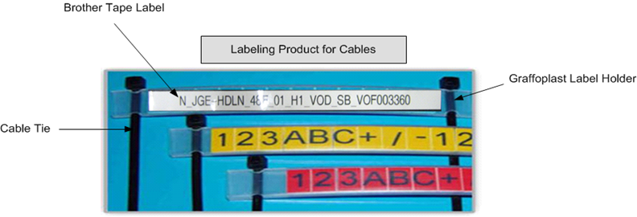

Example of Graftoplast Label:
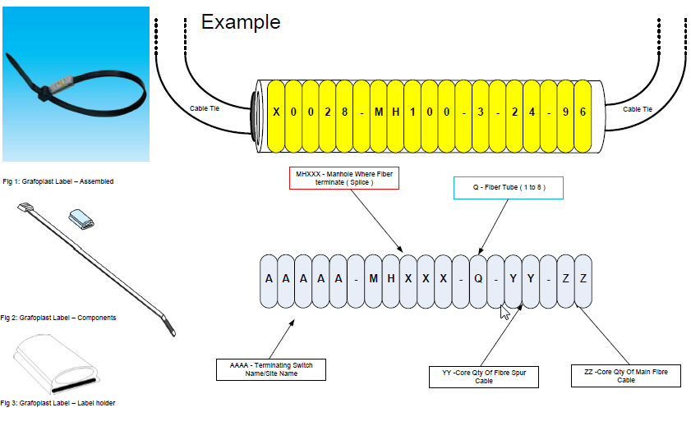

Table 79 Product Specification for Cable Labels

Power Components to be labelled:
Power Type | Power Label
A-Feed | A-Feed1 (Number 1 to 12)
B-Feed | B-Feed1 (Number 1 to 12)
Earthing Bar | Label to be visible where it enters the floor:  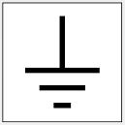
Circuit Breaker | The Label must show which circuit or appliance the Circuit Breaker controls.
Shelf Types | Label as:
 | Photonic Shelf
 | OTN Shelf
 | OTS Shelf
 | Flex Shelf
Fan | Fan
Filters | Filter
Table 80 Broadband Interface Types

Vodacom Manhole and/or Pole Label Specification:

Product | Specification | Usage
Aluminium plates | Anodized aluminium marker plates 80 x 60 mm | Plate to be bonded on the Manhole or Pole with a number to mark the Manhole or Pole for Inventory and Asset Management
Bonding Tape or Epoxy | 3M™ VHB™ Tape 4941  or  Epoxy to bond Aluminium to Cement | The aluminium marker plates are to be attached to the Cement Pole 2 meters from the ground up.
Cleaning Hand Pad | 3M Scotch-Brite General  Purpose Hand Pad 7447  (to clean surface) | To clean the Cement Pole surface before the Epoxy or Bonding Tape are applied.
Tape Primer | 3M Tape Primer 94 | This will be used to label the which are changed regularly like patch cables (tails) between devices
Universal Stamping Kit | 3/8” 10MM Letter & Number Punch Stamp Set Metal-Steel-Hand A-Z *BIG SIZE* 36Pcs | The number is punched-in with the ‘universal stamping kit’ specially designed to ensure that the numbering is perfectly aligned.

Table 82 Vodacom Manhole or Pole Label Specification

Example and dimensions of anodized aluminium marker plates
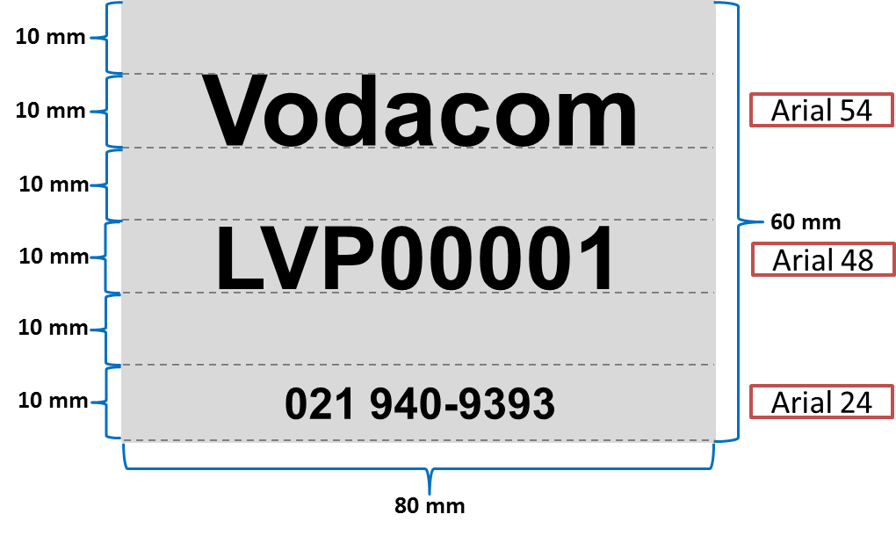
Note: The Plate should be 2mm thick

a. The Manhole or Pole identification number consists out of 3 x ‘pre-printed’ letters unique to the region e.g. LVP and a 5 digit number identifying the Pole number in that specific region.
b. The Manhole or Pole number is punched-in with the ‘universal stamping kit’ specially designed to ensure that the numbering is perfectly aligned.
c. The aluminum marker plates are attached to the Manhole or Pole with 3M VHB bonding tape.

